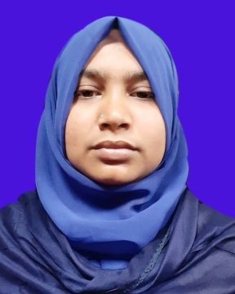
BILKIS ARA CHOWDHURY
bilkisarachowdhury@gmail.com
Mobile: +8801734796549

OBJECTIVE:
My goal is to obtain a dynamic, challenging opportunity that contributes to the outstanding success of any Institute or Organization to pursue long term successful career through my skills, hard work, dedication and determination.

Personal Details:

Name : BILKIS ARA CHOWDHURY
Father’s Name : ABDUL KAIUM CHOWDHURY
Mother’s Name : PEYARA BEGUM
NID : 775 499 0781,
Date of Birth : 05.01.1995
Mobile : 01734796549
Email : bilkisarachowdhury@gmail.com

EDUCATIONal details:
Examination/Degree | Board/  University | Institute | Result | Group/Major | Year
Diploma In Medical Faculty (D.M.F) | The State Medical Faculty of Bangladesh | Moulvibazar Medical Assistant Training School (Moulvibazar MATS) | Passed |  | 2018
M.Sc. in Fisheries | National University | Moulvibazar Government College | On Progress | Fisheries | 2019
B.Sc. (Hons.) in Zoology | National University | Moulvibazar Government College | CGPA 3.41  (Out of 4.00) | Zoology | 2017
HSC | Sylhet | Moulvibazar Government women's College | GPA 3.50  (Out of 5.00) | Science | 2013
SSC | Sylhet | Tilagaon A AN High school, Kulaura | GPA 4.19  (Out of 5.00) | Science | 2011

Professional Qualification
Certification | Institution | Location | From | To
Internship | 250 Beded Sadar Hospital, Moulvibazar | Moulvibazar Sadar | 17 July, 2017 | 17 March 2018
Internship | Upazila Health Complex, Kulaura | Kulaura, Moulvibazar | 04 April, 2018 | 04 July, 2018

Job Experience :
1) I am working with the Surjer Hashi Network (S.H.N) as a Medical Assistant 01/10/2018 To Till Now, Kulaura, Moulvibazar.
2) I was worked with the SSKS NGO as a Medical Assistant 14/08/2018 To 30/09/2018, Kulaura, Moulvibazar.

Computer Skill: MS Office, Internet Browsing, Email.
PRESENT ADDRESS:
Uttarmulaim, Chadnighat
P.O: Moulvibazar
P.S :Moulvibazar Sadar
District: Moulvibazar
Mobile: 01734796549
ERMANENT ADDRESS:
Village: Assroygram
P.O: Tilagaon
P.S :Kulaura
District: Moulvibazar-3231
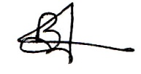
Mobile: 01734796549

-----------------------
(Bilkis Ara Chowdhury)
Date: 26 April, 2020

