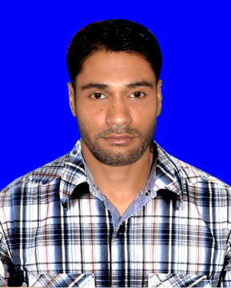
Binoy Chondro Howlader
Address: 34/6 Blok-D Cecsion-10
Mirpur-10, Dhaka
Mobile : 01781494054, 01918848538

Career Objective:

To pursue a challenging career in dynamic organization especially in Developing Organization, where I shall have opportunity to utilize my talent and knowledge as well as prove my skills for professional career development. I maintain honesty, punctuality and respect.

Academic Qualification:
Exam Title | Concentration/ Major | Institute | Result | Pas. Year
H.S.C | Humanities | Helal Uddin Ahamed Degree College, Barisal. | GPA: 2. 25 | 2009
S.S.C | Business Studies | Kajlakati Secondary School, Barisal. | GPA:4.69 | 2005

Computer Skills:
Operating System : Windows 98/ 2000/2007 XP/ Windows 7.
Software Application: Microsoft word.
Microsoft Excel.
. Graphic Desing.
Photosop Edating.
Language Proficiency:

Language | Reading | Writing | Speaking
Bangla | High | High | High
Engish | High | High | Medium

Personal Details :

Name : Binoy chondro
Father’s Name : Chita Ranjon
Mother’s Name : Chapola Rani
Date of Birth : 05 Des, 1989
Gender : Male
Marital Status : Unmarried
Nationality : Bangladeshi
Religion : Sanaton (Hindu).
Permanent Address : Modhokati, Howlader Bari- 8280,
Bakergonj, Barisal
Present Address : 34/6 Blok-D Cecsion-10 , Mirpur-, Dhaka
Current Location : Dhaka.
Self Assessments:
- Sincere and devoted to duties
- Hardworking, Disciplined and Steady
- Better learning Capacity
- Keen eyesight and better sound analytical ability
- Better ability to a take the duties, responsibilities and pressure

Declaration:
I do hereby declare that the particulars, mentioned above, are true to the best of my knowledge and belief.

Sincerely –

Binoy Chondro Howlader

