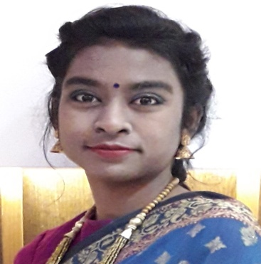
CURRICULAM VITAE
ACHYA AKTER
1st ladies hall, B block/111, Sust, Sylhet.
Contact no: 01778-018282
Email address: jerin8282@gmail.com.

Career objective
Seeking for a job to pursue a highly rewarding career and healthy work environment where I can utilize my skills and knowledge efficiently for the organizational growth.

Educational Qualification:
Exam Name | Board | Institution | Passing Year | Result | Group
SSC | Sylhet | NGFF school, fenchugonj, Sylhet | 2012 | 4.81 | B. Studies
HSC | Sylhet | Metrocity womens college, uposhohor, sylhet | 2014 | 5.00 | B. Studies
BSS(Honor’s in Anthropology) |  | Shahjalal univeraity of science and technology, sylhet | 2019 | Appeared | School of social  science

Computer skill:
- Computer Certification course with ‘A+’ grade.
- Expert in Microsoft word
- Expert in Microsoft Excel
- Expert in Microsoft PowerPoint
- Expert in network browsing

Achievements:
- Champion at interuniversity carom tournament
- Champion at inter departmental handball tournament
- Runner-up at inter departmental cricket tournament
- Champion at inter departmental badminton tournament

Interests:
- Internet Surfing.
- Adventure Sports.
- Traveling.
- Social Service.
- Singing.
- Interact with people.

Strength:
- Hard working
- Optimistic
- Honest
- Can work under pressure
- Can convince people easily
- Good team worker

Linguistic skills
Language | Speaking | Reading | Writing
Bengali | Excellent | Excellent | Excellent
English | Medium | Excellent | Medium

Personal Information:
Name: Achya Akter Jerin
Father’s name Abul Kashem Chokder
Mother’s name Hasni Ara Begum
Permanent address vill: Dohar; Post office: Dohar; District: Dhaka
Present address 1st ladies hall, B/111, Sust
Date of birth 12/08/1996
Nationality Bangladeshi
Religion Islam
Gender Female
Marital status Single

