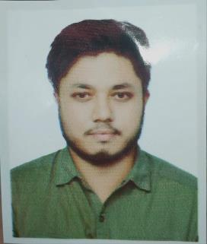
CURRICULAM VITAE
Of
MD. Zahidur Rahman Hasan
House No:- 109 Sunar bangla Bagbari, Sylhet
Contact Number:- 01752090024
E-mail:- Zahidurrahman36@live.co.uk
CAREER OBJECTIVE
To enter in a well-reputed organization in a position having the intention to work with honestly, sincerely and to learn for growing eventually to take greater responsibilities and to face challenges of the time and to again experience & skills for successful career pathway
ACADEMIC QULIFICATIONS
BBA (Honor’s)
- Name of University : North East University (NEUB)
- Department : Bachelor of business Administration
- Year of passing : On going (10th Semester)

Higher secondary Certificate
- Board : Sylhet
- Institution : Inatgonj collage, Nabigonj
- Group : Humanities
- Year Of passing : 2016
- Result : GPA 2.67
Secondary school Certificate
- Board : Sylhet
- Institution : Inatgonj High School, Nabigonj
- Group : Humanities
- Year Of passing : 2014
- Result : GPA 3.38
COMPUTER SKILLS
- Basic skills, Microsoft word, Microsoft PowerPoint, Microsoft Excel,
- Have good knowledge of using internet & E-mail, And maintain pages and groups

EXTRA CURICULAM
- I also active on various social welfare activities & cultural program
- Good in public relation & excellent in communication skills
- Capable to work in a team with co-operative & friendly attitude
PERSONAL DETAILS
Father’s name : MD. Azizur Rahman
Mother’s name : Samsunnahar
Date of birth : 02/01/1996
Nationality : Bangladeshi
Sex : Male
Marital status : Unmarried
Religion : Muslim
Permanent address : Bagbari, House no. Sunar bangla 109, Sylhet
HOBBIES
- Traveling
- Reading books
- Playing outdoor games ,cricket, Badminton

REFERENCES
Md. Nasir Uddin
Lecturer of business administration
(North East University Bangladesh, Sylhet)
Mobile : 01717638643

Signature
…………………………………..
(Md. Zahidur Rahman Hasan) Date:-

