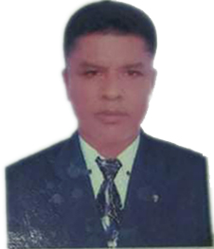
CURRICULM VITAE
TARIQUL ISLAM KHAN
Present Address:
Purura 5no, Ward, Bhaluka,Mymensingh,Bangladesh
Home Phone : +8801711039870, +8801771854834
E-Mail Address: ti4590282@gmail.com

SPECIAL QUALIFICATION

CDL Driver (heavy driver)

CAREER OBJECTIVE
To build a carrier involved in innovative activates with high growth opportunities. For achieving the best i want to utilize my talents. I want opportunities where i can use my intellectual ideas and show my responsibilities to my job.

EDUCATION QUALIFICATION
INSTITUTE NAME
M.COCCO
Pro.M.M driving center
Mymensingh,Bangladesh
Registration number : 21/355/1994 is hereby awarded this certificate upon his successful completion of the coures driving . During 05.08.1994 to 10.09.1994 given this certificate on the 12 day of 09. 1994.

- Diploma in Mechanical certificate, Mymensingh Polytechnic Institute,Mymensingh, Bangladesh.

CAREER SUMMARY

Hard Worker, Sincere, Punctual, Good Interpersonal & Motivational Skill

JOB EXPERIENCE: 21 YEARS

- Company name : Saudi Telecommunication (Saudi Arabia)
Duration : 14 Years at 1994 to 2008 .
- Company name : Bondhu Transport ltd. in ( Dhaka)
Duration : 07 Years at 2010 to 2017 .

LANGUAGE PROFICIENCY

Language | Reading | Writing | Speaking
Bangla | High | High | High
English | Medium | Medium | Medium
Hindi | Medium | Medium | High
Arabic | High | High | High

SPECIAL INTEREST
- Music, Sports, Singing, Reading, Networking, & Traveling.
PERSONAL INFORMATION

Name : TARIQUL ISLAM KHAN
Father’s Name : Abdur Razzak Khan
Mother’s Name : Fazila Khatun
Contact : +8801711039870
Date of Birth : 01/01/1972
Nationality : Bangladeshi By Birth
Marital Status : Married
Religion : Muslim
Blood Group : O (+) Positive
Permanent Address : Purura 5no Ward, Bhaluka, Mymensingh, Bangladesh .

SELF ASSESMENT
I am sincere, honest, hardworking, self-motivated and reasonably presentable person having positive attitude towards working with good interpersonal relations with different nationals and religions.

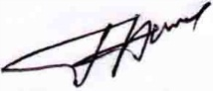

Signature

