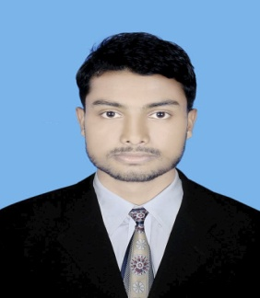
CURRICULUM VITAE

Full Name : Humayun Kabir
Father’s Name : Kazi Amir Hossen
Mother’s Name : Baby Khanam Bedana
Present address : Vill: West Jahidpur, P.O: Nabiganj, P.S: Nabiganj, Dist: Habiganj.

Permanent address : Vill: West Jahidpur, P.O: Nabiganj, P.S: Nabiganj, Dist: Habiganj.
Date of Birth : 17/07/1997
Nationality : Bangladeshi (by birth)
Religion : Islam
Marital Status : Unmarried
Sex : Male
Contact No : +8801730-244451

Educational Qualification:
Name of Exam | GPA Grade/Division | Passing Year | Group/ Sub | Board
S.S.C | 3.78 | 2015 | Humanities | Sylhet
H.S.C | 2.50 | 2017 | Humanities | Sylhet

Date & Signature

