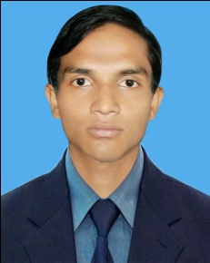

Photo

CURRICULUM VITAE

MD. AKMOL HUSSAIN APU

Mailing Address: Vill: Choru goan, P.O: Tukerbazar,
P.S: Jalalabad, Sylhet-3100. Bangladesh.

Contact No: +8801782-333550
E-mail : akmol3100@gmail.com

Career Objective

To pursue a career at highly challenging environment, providing scope for an enriching work experience leading to career developing opportunity through accelerated learning and creativity skills.

Education

- Bachelor of Business Studies (Accounting)
Institution : Gobindoganj Abdul Haque Smriti College.
Board : National University.
: Studied 3nd Year Running
- Higher Secondary Certificate (H.S.C):
Institution : Madan Mohan College
Board : Sylhet

Group : Business Studies

Result : 3.70
Year of Passing : 2013
- Secondary School Certificate (S.S.C):

Institution : Hazi Abdus Sattar M.L. High School
Board : Sylhet
Group : Science
Result : 4.38
Year of Passing : 2011

Computer Skill

MS Word, MS Excel, Ms PowerPoint, Internet Browsing & Networking.

Works Experience:

- I have worked as Auto Mechanics at UCEF Bangladesh. From 6 month still.

Personal Details

Name : Md. Akmol Hussain Apu
Name of Father : Sirajul Islam
Name of Mother : Dilara Begum
Date of Birth : 01/05/1995
Religion : Islam
Married Status : Unmarried
Nationality : Bangladeshi (by birth).
Blood group : O+ (Positive)
Present Address : Vill: Choru gaon, P.O: Tukerbazar,
P.S: Jalalabad, Dist: Sylhet.
Permanent Address : As Above

Declaration

I, the undersigned, declare that the information given in these curriculum vitae is true to the best of my knowledge.

MD. AKMOL HUSSAIN APU

Signature

Date:

Job Experience

