Mobile No: +8801774-956333
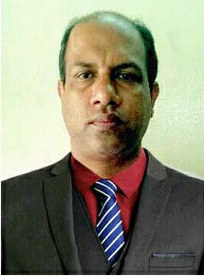
CURRICULUM VITAE

GOAL
My goal is to work with a vision, which would help me to achieve success even in the most competitive and stressful environment. I am a quick learner and I believe I can reach my goal as long as I have the strength, courage and willingness to discover the unknown in the shortest time possible.

1. Name : Toslimur Rahim Joarder.
2. Father’s Name : Mohammad Abdur Rahim Joarder.
3. Mother’s Name : Begum Mofida Joarder.
4. Permanent Address : DMC, 916 Ibrahimpur, Dhaka Cantonment, Dhaka1206.
5. Present Address : Bihongga 67/A, Kazitula, Sylhet.
6. Date of birth : 20-02-1977
7. Religion : Islam (Sunni)
8. Nationality : Bangladeshi (By birth)
9. Blood Group : (O+)
10. Marital Status : Married
11. Mail Address : taslimjoarder@gmail.com
12. Academic Achievements :

DEGREE OBTAINED | PASSING YEAR | RESULT | BOARD OF EDUCATION
S.S.C | 1992 | 1st Division | Dhaka
H.S.C | 1995 | 2nd Division | Dhaka
Degree (B.S.S) | 1997 | 2nd Division | National University
M.S.S | 1999 | 2nd Division | National University
ICDL (International Computer Driving License) | 2010 | ICDL Certificate and ICDL Start Certificate | ECDL Foundation

Computer Literacy:
Successfully completed introduction to computer application package and programming (Introduction, MS-Word, MS-Excel, MS-Power and Internet & E-mail).

Experience:
Past Job:
- Steno Typist cum Computer Operator,
Project Director, Construction of 19 & 12 District Jail Project, Ministry of Home Affairs, Dhaka. From 1st March 1999 to June’2011.

- Activator (IT Section),
REC Corporation (GrameenPhone Distribution House), Anonda Tower, Sylhet. From 1st October’2011 to September’2014.

Current Job:
- Now serving in Sylhet City School as Computer Operator from 2015.

Signature
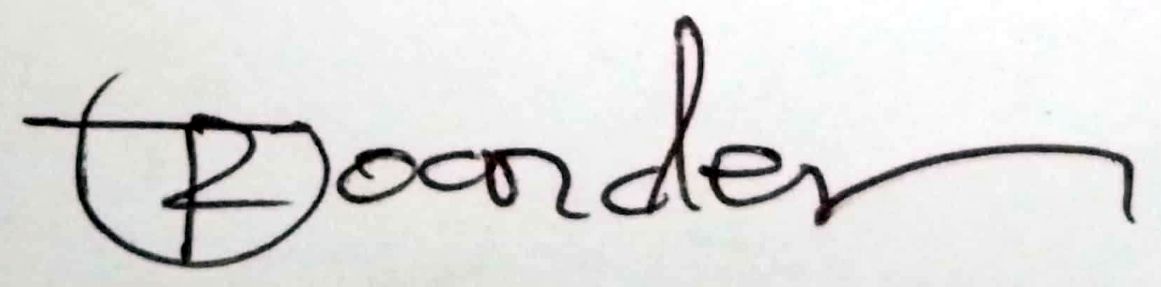
(Toslimur Rahim Joarder)

