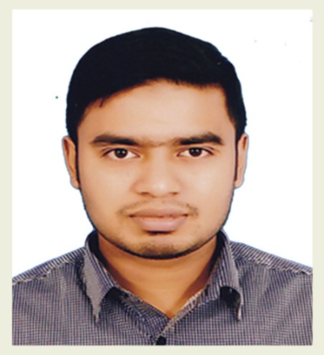
CURRICULUM VITAE
OF
Md. Aktar Hussain
Contact No: +880 1722-593320
E-mail: akthergreen@gmail.com

CAREER OBJECTIVES
Looking for hard and challenging jobs where I will have the scope to utilize my potentiality, Adaptability and skill and to do something innovative and from where I will be able to enhance my knowledge.

PERSONAL INFORMATION
Name: Md. Aktar Hussain
Father’s Name: Md. Rezaul Islam
Mother’s Name: Dilara Begum
Mailing Address: House 3, Road 31, Block D, Shahjalal Uposhohsor, Sylhet.
Permanent Address: Village- Chand Gram, Upazila- Barlekha, District- Moulvi Bazar.
Date of Birth: 18-02-1992
Gender: Male
Marital status: Unmarried
Blood Group: B+(ve)
Nationality: Bangladeshi (By Birth)
Religion: Islam
EDUCATION

Masters’ of social science (M.S.S)

- Board: National university of Bangladesh.
- Institute name: M. C. College, Sylhet.
- Subject: Economics.
- Duration: 1 Year.
- Result: Pending

Bachelor of social science (B.S.S)

- Board: National university of Bangladesh.
- Institute name: M. C. College, Sylhet.
- Year of passing: 2013
- Subject: Economics.
- Duration: 4 Years.
- Result: 2.54 out of 4.00

- Higher secondary certificate:

- Board: Madrasha
- Institute name: Chandgram A. U. Fazil Degree Madrasha.
- Group: Humanities
- Year of passing: 2009
- Result: 3.58 out of 5.00

- Secondary school certificate:

- Board: Madrasha
- Institute name: Chandgram A. U. Fazil Degree Madrasha.
- Group: Humanities
- Year of passing: 2007
- Result: 3.92 out of 5.00

PROFESSIONAL TRAINING

- CCNA: Cisco Certified Network Associate (Academic)

- Institute: Shahjalal University of Science & Technology.
- Duration: 1 Year (4 semester)
- Year of passing: 2016-17
- Result: Successfully completed with letter.

- CCNA Vendor: (Applied)

- Linux (RHCSA): Operating system

- Institute: Cloud systems limited (CSL), Dhaka.
- Duration: 3 Month.
- Result: Successfully completed.

- CCNA: Cisco Certified Network Associate (V:3)

- Institute: New Horizon Computer Learning Centers, Dhaka-1205.
- Duration: 3 Month.
- Result: Successfully completed.

COMPUTER SKILLS

- Operating System: Windows 98, XP, 7, 8, 8.1 &win10, Linux mint17.
- Application Package: MS. Word, MS. Excel, MS. PowerPoint, outlook.
- Other: Internet Browsing and E-mail.

LANGUAGE PROFICIENCY

- Good at Reading & Writing in English, well in Speaking.
- Excellent in Bengali Literature and Composition

Experience
- Trainer (Office Management & ICT) at Hexa’s Zindabazar, Sylhet.
- Trainer (Office Management & ICT) at Hexa’s Ambarkhana, Sylhet.
- Trainer (Office Management & ICT) at Hexa’s Uposhoshor, Sylhet.

Interests

I love meeting new people and making friends, travelling, reading story books and
listening music. I also love to keep myself updated so that in my spare time I watch
news or read newspaper, magazine.

REFERENCES
Reference: 01 | Reference: 02
Juber Ahmed  Managing Director  Hexa’s Uposhohor, Sylhet.  Mobile +880 1779 900449 | Sultan Ahmed  Managing Director  Hexa’s Zindabazar, Sylhet.  Mobile +880 1723 508860

I confirm that to best of my Knowledge the information given herewith is true, authentic and up-to date.

Signature
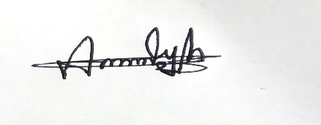
(Md. Aktar Hussain)
Date: 14.03.2018

