CURRICULUM VITAE
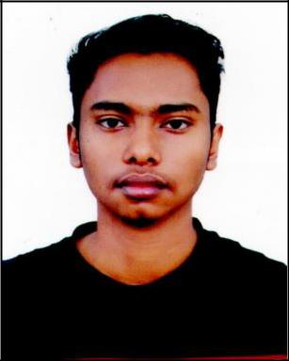

KAWSAR AHMED
^{Cell: +88 01760-625304} Shornoshika, Kodomtoly, Sylhet
E-mail: kawsar121.ka@gmail.com

Objective

To obtain a challenging position in any area of Business that will provide future opportunities for growth and development and to use my skill and experience that. I have acquires on my education life and to dedicate my whole effort to achieve the organizational goal.

Academic Qualifications

- Bachelor of Business Administration (BBA)

Major : Marketing
Result/Status : CGPA-2.73 out of 4
University : Leading University, Sylhet.

- Higher Secondary Certificate (H.S.C)

Stream : Business Study
Result/GPA : 2.61
Institute : Madan Mohan College
Board : Sylhet
Passing Year : 2014

- Secondary School certificate (S.S.C)

Stream : Humanities
Result/GPA : 3.75
Institute : Jalalpur High School
Board : Sylhet
Passing Year : 2012

- Good communication skills
Strength

- Quick learner
- Good leadership
- Able to work at any time at any place
- Ability to work with a team.

Language Proficiency

- Excellent command and writing capability in Bengali & English both.
Computer Skill

- Proficient in Microsoft Office Applications.
- Having Knowledge on Internet browsing and E-mail.
Extra-Curriculum Activities

- Co-Founder at Gateway Bangladesh
(This is common online education network platform and associate with 10 Minute School in Sylhet region)
- Joint Secretary at Leading University Photographic Society.
- Leading University Mock Model United Nation
(Representing BANGLADESH on UNDP)

Personal Details

Name | : | Kawsar Ahmed
Father’s Name | : | Md. Manir Miah
Mother’s Name | : | Rahena Begum
Sex | : | Male
Marital Status | : | Single
Nationality | : | Bangladeshi
Date of Birth | : | December 1, 1995
Blood group | : | O+
Permanent Address | : | Jalalpur, South Surma, Sylhet
Present Address | : | 141 SR Tower, Block #B, Shornoshika, Kodomtoli, Sylhet.
Personal Details

Md. Jahangir Alam Shadeul Alam Khan
Assistant Professor Senior Lecturer
Department of Business Administration Department of Business Administration
Leading University, Sylhet Leading University, Sylhet
Mobile: +8801711009899 Mobile: +8801670565548
E-mail: jalam@yahoo.com E-mail : shahed-shuvo@yahoo.com

Note:


I would be appreciated if you give me an opportunity to work with you and to execute myself with your support. All the information provided here are correct and complete.

................................
Kawsar Ahmed
Date: 17-06-2019

