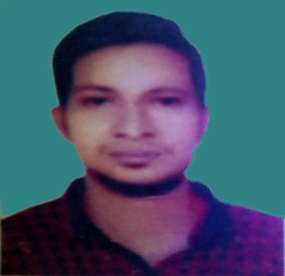
CURRICULUM VITAE
OF
RASAL
(MOBIL NO: 01575311360)
E-mail : raselkhan01927235421@gmail.com

Career Objective:
To pursue a career in a dynamic organization in which I will have the opportunity for professional career development.

Educational Qualification:

BBA (bachelor of business Administration)

Institute : GOVT.BANGLA COLLAGE ,Dhaka

Subject : Accounting

Result : CGPA-2.60

Passing Year : 2015

H.S.C (Higher secondary School Certificate)

Institute : BCIC Collage

Group : Commerce

Board : Dhaka

Result : GPA – 4.10

Passing Year : 2011
H.S.C (secondary school Certificate)

Institute : cherihakanna Botanical High school

Group : commerce

Board : Dhaka

Result : GPA -4.56

Passing year : 2009

Computer Literacy:

- Microsoft office (MS word, MS Excel, MS Power point MS Access )
- Executive Knowledge in internet activities

Interest:

- Reading Book
- Learning new things
- Excursion
Language Proficiency:

Have fluency in English & Bengali in both Speaking & Writing.

Hobbies :

Traveling, Playing, Reading books & Photography.

Strength:
- Hard
- Punctual
- Determined
- Believe in myself, self-confidence
- Highly energetic
Personal Details:

Name : Rasel
Father name : Abdulhalim
Mother name :Roushanabegum
Nationality : Bangladeshi from birth
Date of birth :3|12|1994
Marital status : single
Sex : male
Permanent Address :vill: Ruspsha .p.O: Musha
DIST: Kisourgonj

