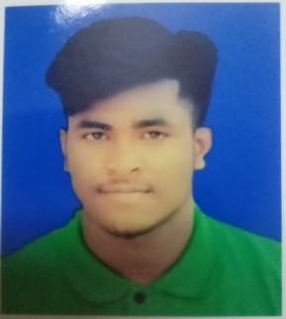
CURRICULUM VITAE

Md. KAMRUL ISLAM
Address : Baruthkhaana,Sylhet Abas 7/A
Phone : 01777924227
Email : xosshiron@gmail.com
Apply for :

OBJECTIVE :
Seeking a challenging opportunity where I will able to utilize my strong organizational skills,educational background & ability to work well with people ,which will allow me to grow personally & professionally.

PERSONAL INFORMATION:
Name : Md.Kamrul Islam
Fathers Name : Mujibur Rahman
Mothers Name : Sofina Begum
Date of Birth : 01-12-2000
Religion : Islam
Nationality : Bangladeshi
Maritul Status : Unmarried
Permanent Adress : Sylhet,Bharuthkhana

EDUCATIONAL QUALIFICATION:

Bachelor of Business Administration (BBA):
Institute : Leading University
CGPA : 2.94 (1st semester)
Higher Secondary Certificate (H.S.C):
Board : Sylhet
Institute : Universal College Sylhet
Group : Science
Result : 3.08
Passing year :2019
Secondary School Certificate (S.S.C):
Board : Sylhet
Institute :Joynogor Bazar High School
Group : Science
Result : 3.95
Passing year :2017

WORK EXPERIENCE:
- Foodpanda
Food Delivery
Jail Road, Sylhet (J.R Tower)
SKILLS:
- Have good communication skill
- Comportable writing & speaking
- Sales Product

