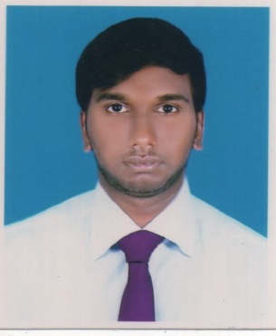
CURRICULUM VITAE
OF
MD. SAJJAD HOSEN
Cell: 01827034160
Email: sajjadtk12@gmail.com
PRESENT Address :
131/A Uttarpara Savar,Dhaka
Permanent Address :
131/A Uttarpara Savar,Dhaka
CAREER OBJECTIVE
To build up a career in a well-established and environment friendly organization where acquired knowledge and expertise can be used effectively and efficiently
SELF ASSESSMENT
- A self-driven attitude, willingness to learn and a strong presence of mind.
- Optimistic, confident and benevolent.
- Energetic, devoted, sincere and hardworking
Academic Qualification
Name of exam | Group/ sub | Year of  passing | Institute/ varsity | GPA /CGPA
Diploma in Engineering | Computer | 2020 | ISLAMI BANK INSTITUTE OF TECHNOLOGY | will be appearing
SSC | BUSINESS STUDIES | 2016 | SAVAR ADHAR CHANDRA HIGH SCHOOL | 3.39
youth development training | Graphics | 2020 | savar | 5.00
Language Proficiency:
Confident Enough to Communicate Both in Bengali and English

JOB EXPERIENCE
COMPANY | POSITION | DURATION
interspeed marketing solution ltd  (IMSL) | BRAND REPRESENTATIVE | 6 MONTH
BRITISH AMERICAN TOBACCO | SURVEYOR | 6 MONTH
PERSONAL PROFILE

Name: MD. SAJJAD HOSEN
Father’s Name: RAFIQ MIA
Mother’s Name: SHAIDA BEGUM
Date of Birth: 19-02-1999
Height: 5.10”
Blood Group O+
Weight: 70 Kg
Religion: Islam
Marital Status: Unmarried
Nationality: Bangladeshi
NID: 6458551626
The information stated above is true

…………………………………………………………
Signature

