CURRICULUM VITAE
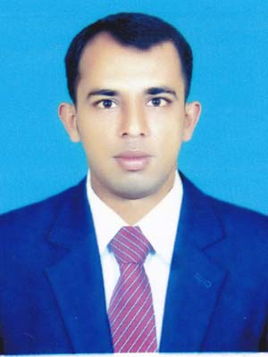

Md. Mohsin Ali
Contract Address:
Vill- Char Vatbera,
Post- Chinadhukuria-6762,
P.S-Ulla para,
Dist- Sirajganj.
Cell # +8801725929679
E-mail : mbmohsin003@gmail.com
Personal Details:

Full Name : Md. Mohsin Ali
Father’s Name : Md. Alauddin
Mother’s Name : Most. Maloti Khatun
Date of Birth : 03 February 1992
Nationality : Bangladeshi by Birth
Permanent Address : Vill- Char Vatbera, P.O- Chinadhukuria,
P.S- Ulla para, Dist- Sirajganj.
Marital Status : Unmarried
Religion : Islam
Sex : Male
Height : 5′ 5″
Weight : 60 kgs
Blood Group : A⁺
Career Objective:
To achieve a challenging position in a progressive organization, where I can take advantage of my skills and creativity as well as discover a new dimension of understanding and learning.
Computer Literacy:

Microsoft Office (Ms Word, Ms Excel, PowerPoint), Photoshop, Internet Browsing & E-mail.

Language Proficiency:

- Excellent command over “English” in reading, writing, listening and speaking.
- “Bengali” is the mother tongue.
Hobbies:
♦Traveling, Listening, Reading Books, Watching Movies, Enjoying Sports, Involvement in Social
Activities.

Academic Qualification:
♦ Master’s of Business Administration : M.B.A
Subject : Management
Passing Year : 2016
Result : 3.34
Institution : Sirajganj Govt. College, Sirajganj .
University : National University

♦ Bachelor of Business Administration : B.B.A (Honour’s)
Subject : Management
Passing Year : 2015
Result : 3.08
Institution : Sirajganj Govt. College, Sirajganj .
University : National University

♦ Higher Secondary Certificate: ( H.S.C)
Group : Business Studies
Passing Year : 2011
Result : GPA-4.40 out of 5
Institution : Rajman College, Sirajganj .
Board : Rajshahi.

♦ Secondary School Certificate: (S.S.C)
Group : Humanities
Passing Year : 2008
Result : GPA- 3.38 out of 5
Institution : Rajman High School Sirajganj.
Board : Rajshahi.
Reference:
Prof. Dr. Hasnan Ahmed  Pro-Vice Chancellor (In-charge)  United International University (UIU)  United city, plot # 02 Madani Avenue, Badda Dhaka-1212  Cell : 01718634057  Email: hasnanahmed@yahoo.com | Md. Mizanur Rahman  Principal  Govt. Rashiduzzoha Mohila College. Sirajganj.  Cell -01716-365512  Email. prof.md.mizanur.rahman@gmail.com

Declaration:

I confirm that, to the best of my knowledge, the information given here is correct and complete.



Md. Mohsin Ali
Date :

