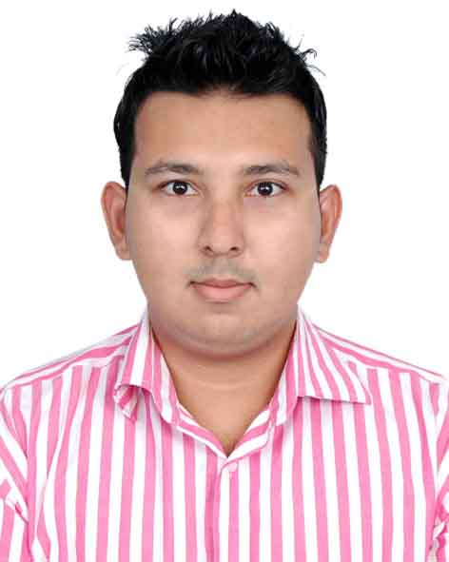

CURRICULUM VITAE

Photo
OF
A.K.M Fazlul Haque

MAILING ADDRESS
125- Focus, Sunar Bangla, Uttar Baluchor, Sylhet.
Phone No. 01946-906268
Parents No. 01929-989501
E-mail: fahimbiplob.fb@gmail.com

CAREER OBJECTIVE
I would like to employ myself in such an activity which is challenging and also creative very much. It will be very pleasant to me if I get such an opportunity, I shall employ my highest ability.

EDUCATIONAL QUALIFICATION

Exam  Name | Institution | Group/  Subject | Year | GPA/CGPA | Board/  University
BSS (Hon’s) | Madan Mohan College | Political Science | 2014 | 2.78 | National University
HSC | Sylhet Model School & College | Business Studies | 2010 | 3.90 | Sylhet
SSC | Kurar Bazar High School | Science | 2008 | 3.50 | Sylhet

EXPERIENCE
Company Name | Designation | Duration | Territory
Westecs Ltd | Sales & Executive | 1 Year | Sylhet Sadar
Alfalah Hospital, Dargha Gate, Sylhet | Receptionist | 6 Months | Sylhet Sadar

COMPUTER SKILLS
Basic Computer Course completed. Specially trained in MS Office, MS Excel, MS Power point, MS Access, Internet and Email etc.

FIELDS OF INTEREST
Any preferable post.

KEY QUALITIES
- Strong aspiration for leading as honest life with dignity.
- Dedication to build a career showing professional attitude.
- Hard working, sincere & keen to learn.
- Able to work under pressure.
- Prepared to take responsibilities.

LANGUAGE COMPETENCY
Bangla : Mother Tongue
English : Fluent both in speaking and writing.

PERSONAL DETAILS
Name : A.K.M Fazlul Haque
Father’s Name : Md. Abul Boyan
Mother’s Name : Musammat Burhana Begum
Date of Birth : 07/11/1991
Permanent Address : Vill: Akakhazana, P.O: Kurar Bazar,
Upazilla- Beanibazar, District: Sylhet
Gender : Male
Religion : Islam
Marital Status : Married
Nationality : Bangladeshi (By birth)

REFERENCE
Ali Ahmed
Businessman
Mendibag, Uposhohor, Sylhet,
Mob: 01716-970688

I certify that all information stated in this CV is true and completed to the best of my knowledge.

Signature:

(A.K.M Fazlul Haque)
Date:

