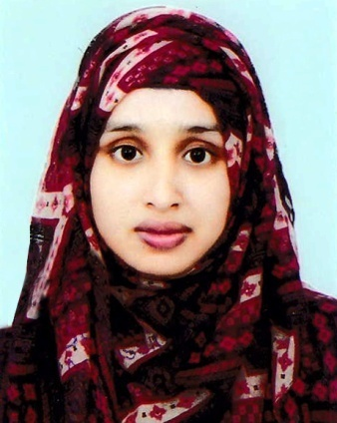
CURRICULUM VITAE
Of
KADEJA TARIN

Mailing Address:
Ark Homes, Hawapara, Zindabazar, Sylhet- 3100
Mobile No. : +88 01786468904
Email : nahimatarin1@gmail.com

Career Objective:
Aim to work creatively in a competitive and challenging working environment with strong responsibility and commitment where job satisfaction and career development will be provided. And to prove myself as a quick learner and highly energetic person to face any challenge in such an organization where the contribution will be acknowledged.

Personal Particulars:
Father's name : Late Mohammad Abdullah.
Mother's name : Rosna Begum.
Date of Birth : 08\03\1994
Nationality : Bangladeshi.
Religion : Islam.
Gender : Female.
Marital Status : Single.
Present Address : Ark Homes, Hawapara, Zindabazar
Sylhet- 3100
Permanent Address : Vill- Fathepur, P.O- Beanibazar, P.S- Beanibazar, Dist- Sylhet

Academic Qualification:

Certificate | Field of study | Version | Name of Institution | Board | Passing Year | Result
BBA | Finance & Banking | English | Leading University |  | 2017 | 3.94on 4.00 Scales
H.S.C | Science | Bangla | Beanibazar Government College | Sylhet | 2012 | 5.00 on 5.00 Scales
S.S.C | Science | Bangla | Beanibazar Girl’s High School | Sylhet | 2010 | 4.88on 5.00 Scales
Computer Skills:
- Microsoft Word
- Microsoft Excel
- Microsoft Power Point
- Internet Browsing.

Language Skills:

Languages | Spoken | Written
Bengali | Yes | Yes
English | Yes | Yes

Experiential Learning (Summer Internship Program):
Company Name : The City Bank Limited.
Branch : Zindabazar Branch, Sylhet.
Duration : Three Months (From 7th May 2017 to 7th August 2017).

References:
Prof. Md. Nazrul Islam  Dean & Head  Department of Business Administration,  Leading University, Sylhet.  Contact: 01718824376  E-mail: head_bua@lus.ac.bd | Dr. Wahiduzzaman Khan  Assistant Professor,  Department of Business Administration,  Leading University, Sylhet.  Contact: 01939993399  E-mail: wzk_roence@yahoo.com

Declaration:

I do hereby declare that the above information correctly describes my qualifications to the best of my knowledge.

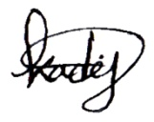

…………………………..
Kadeja Tarin
Date:

