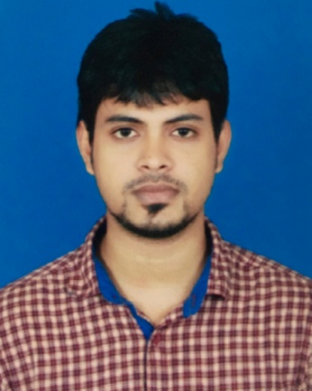
Curriculum Vitae of

Photo

MD. ABU TAHER
Mailing Address:
HAZI ANWARA KHATUN VILLA,
LAMAPARA SHIBGONJ,
MUHINI-509,
SYLHET 3100.
Contact:+8801731506372
Email:taher.syl93@gmail.com
CAREER OBJECTIVES :
Achieving a dynamic and challenging job where I could use my educational, professional and interpersonal skills that will add desired value to your organization and develop my career with the best effort.
EDUCATIONAL QUALIFICATION :
Master of Business Administration (MBA) :
Institution : Leading University, Sylhet.
Program : Masters of Business Administration.
Result : CGPA 3.77
Major Subject : Accounting
Bachelor of Business Administration (BBA) :
Institution : Sylhet International University (SIU).
Passing Year : 2016
Result : CGPA 3.18 (Out of 4.00)
Major Subject : Accounting
Higher Secondary Certificate ( H.S.C) :
Institution : Scholarshome, Sylhet.
Passing year : 2011
Result : GPA 3.50 (Out of 5)
Group : Humanities
Board : Sylhet
Secondary School Certificate ( S.S.C) :
Institution : Paigaon High School.
Passing year : 2009
Result : GPA 3.44 (Out of 5)
Group : Humanities
Board : Sylhet

COMPUTER LITERACY :
Good command on following application:
- Higher Diploma in Computer Science and Technology (1Year) from NYDCBA.
- Microsoft Word
- Microsoft Excel
- Microsoft Power Point
- Internet Browsing
- E-mail.

LANGUAGE PROFICIENCY :
- English: Can speak, read, write and understand.

STRENGTH:
- Ability to work under pressure efficiently and independently with good self presentation.
- Ability to create excellent interpersonal relationship and good team work.

EXPERIENCE:
- 03(Three) months internship at Premier Bank Limited,Amberkhana Branch,Sylhet.
- Working Under Grameenphone SME distributor as a Sales Executive from 7th February to 30th May,2018.
- Working Under Bangladesh Election Commission as a Data Entry Operator from June.2018.
- Members of Human Rights And Education Society BD.

INTEREST AND HOBBIES:
- Travelling new places.
- Playing games like cricket, football, badminton etc.
- Reading books, magazines, newspapers etc.
- Watching movies.
- Net browsing.

PERSONAL DETAILS :
- Name : Md. Abu Taher
- Father’s Name : Md. Abdur Rajjak
- Mother’s Name : Gondro Mala Begum
- Religion : Islam
- Nationality : Bangladeshi (by birth)
- Date of birth : 22nd April 1993
- Sex : Male
- Marital Status : Unmarried
- Height : 5'4"
- Permanent Address : Vill:Monbeg,Post: Gonipur,
P.S: Dakshin Sunamgonj,
Dist: Sunamgonj, Bangladesh.
Present Address : HAZI ANWARA KHATUN VILLA,
LAMAPARA SHIBGONJ,
MUHINI-509,
SYLHET 3100.

REFERENCE :
 |  | Reference: 01 | Reference: 02
Name | : | Dr. Wahiduzzaman Khan | Mr. Abu Syeed Muhammed Abdullah
Organization | : | Leading University,Sylhet. | Sylhet International University,Sylhet.
Designation | : | Associate Professor Head Business Administration of Leading University,Sylhet. | Assistant Professor & Head of the Department Of Business Administration in Sylhet International University.
Mobile | : | +88019 39993399 | +8801751232222
E-Mail | : | wzk_roence@yahoo.com
Relation | : | Academic. | Academic.

DECLARATION :
I, the undersigned, certify that to the best of my knowledge and belief, these curriculum vitae correctly described.

...............................
(Md. Abu Taher)
Date: 28.0.2019

