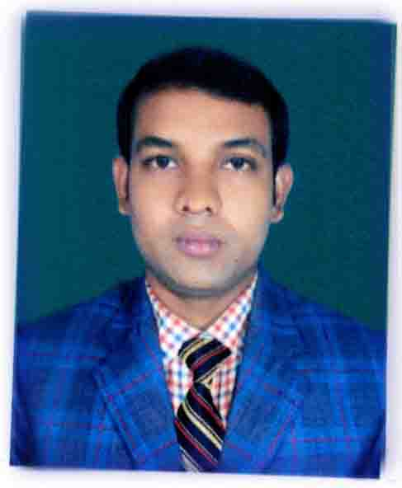
CURRICULUM VITAE
Of
Md. Moshiur Rahman
Cell: 01740-193363
e-mail: moshiurte30@gmail.com

CARREER OBJECTIVE:
To secure a position with a well-established organization with a stable environment that will lead to a lasting relationship in the field of Business. To obtain a position that will enable the use of my strong organizational skills and ability to work well with people.

EDUCATIONAL QUALIFICATION:

B.Sc in Textile Engineering :

Institute : Daffodil International University.
Year of Passing : 2018
Result : 2.63 (Scale of 4.00)

Higher Secondary School Certificate (HSC):
Institute : Mithapukur Degree College.
Name Group : Science
Year of Passing : 2009
Result : 3.30
Name of Board : Dinajpur Board

Secondary School Certificate (SSC):
Institute : Mithapukur High School.
Name Group : Science
Year of Passing : 2007
Result : 5.00
Name of Board : Rajshahi Board

TRAINING:
Training Title | Topic | Institute | Location | Duration
Industrial Attachment | Compacting | KAC Knit Wears LTD. | Chakrabarti, Ashulia, Savar, Dhaka. | 4 Months

COMPUTER SKILL:

M.S Word, Power point, Excel, Internet Browsing.
Preparing Technical reports and documentation in English.
LANGUAGE SKILL:

Bangle: Native, excellent (Both written and conversation)
English: Excellent (Both written and conversation)

STRENGTH :

Self-Confident
Ability to work in Groups.
Willingness to accept directions
Fast to learn new things from others.

PERSONAL INFORMATION:

Name : Md.Moshiur Rahman
Father’s Name : Md. Ashraful Alam Azad
Mother’s Name : Most. Hadison Nesa
Date of Birth : 15th May, 1992.
Religion : Islam
Marital Status : Single
Gender : Male
National ID no : 2819739224
Blood Group : O+
Nationality : Bangladeshi
Permanent Address : Vill- Anontorampur, P.O- Anontorampur, P.S- Pirgonj, Dist- Rangpur.
Present Address : Vill- Mithapukur (Adorshapara), P.O- Mitapukur, P.S- Mithapukur, Dist- Rangpur.

Experience:

- Worked as Lab-assistant at Tua-Ha-Textiles Ltd, Kabirpur, Zirani, Ashulia, Savar, Dhaka, from 01/08/2015 to 20/12/2015.
- I worked as an assistant teacher at-
- Bokshi Adorsha Public School, Bat-tala, Zirani, Ashulia, Savar Dhaka, from
01/01/2016 to 31/12/2016.

- Setu-Biddya Niketon, Telibari, Zirani, Ashulia, Savar, Dhaka, from 01/01/2018 to 20/01/2019.

- Now, I am working as Vice-Principle at Mithapukur Textile Engineering Institute, Paglarhat, Mithapukur, Rangpur.
DECLARATIONS OF AUTHENTICITY:

I the undersigned certify that this personal resume correctly describes my qualifications and myself.

_________________
Md.Moshiur Rahman
Date :01/09/2020

