 | Curriculum Vitae  Of  Pollobi Bhattacharjee | 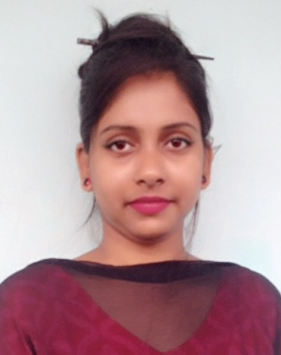

MAILING ADDRESS:
Pollobi Bhattacharjee
C/O: Dhiresh Bhattacharjee.
Vill- Teliapara, Post- Teliapara, U.P- Madhabpur,
Dist- Habiganj.
Mobile No: 01785658532.
Email: pollobi8532@gmail.com.

CARRER OBJECTIVE:
Intend to work in challenging and competitive environment where the strong sense of responsibility and commitment to learn & grow are valued. I would like to establish myself as a successful professional with full dedication to the organization.
OTHER’S EXPERIENCE:
- Having practical experience in computer-MS Word, MS Excel, MS Power Point.
- E-mail and Internet Browsing.
HOBBY:
- Fine-Art & Interior Design.
- Gardening.
- Reading Books.
EDUCATIONAL QUALIFICATION:
Name of Examination | Year | Division/Class/CGPA | Group/Subject | Board/ University.
BA-Hon’s(English) | 2017 | 3.27 | English | Sylhet International  University ,Sylhet.
HSC | 2012 | 4.00 | Science. | Comilla.
SSC | 2010 | 3.94 | Science. | Sylhet.

LANGUAGE’S SKILL:
- Bengali (Mother Tongue) read, write & speaking.
- English (Read, Write & Speak).
PERSONAL DETAILS:
Father’s Name : Dhiresh Bhattacharjee.
Mother’s Name : Swapna Bhattacharjee.
Permanent Address : Vill- Teliapara, Post- Teliapara, U.P- Modhabpur,
Dist- Hobigonj.

Present Address : 1-No, Female Hostel,Sylhet International University,
shamimabad, Bagbari, Sylhet.

Nationality : Bangladeshi.

Date of Birth : 27/06/1995.
Marital Status : Unmarried.
Height : 5 feet 5 inch.

REFERENCE:
- Mr. Prodhan Mahbub Ibna Seraj.
Head, Department of English.
Sylhet International University.
Email: mahbubdu511@yahoo.com.
Mobile No: 01727-191342

- Mr. Syed Hasan Mahmud.
Asst. Professor, Department of English
Sylhet International University.
Email: hasan2enn@yahoo.com.
Mobile No: 01723-490126.

I certify that all information stated in this resume is true and complete to the best of my knowledge.

Signature:

……………………………
(Pollobi Bhattacharjee.)

