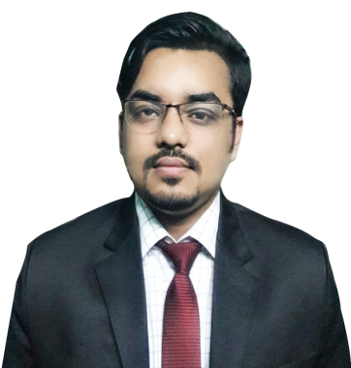
RESUME OF
MUSTAFIZUR RAHMAN
Present Address: Contact Address:
Waves 40, Chandantula, Email: mrsany.mu@gmail.com
Amberkhana, Sylhet, 3100. Cell phone: +88-01751285867/
Permanent Address: +88-01621694899
Vill: Kalaguja, P.O: Selimgonj
P.S: Jamalgonj, District: Sunamgonj.
Career Objective:
To secure a position where I can efficiently contribute my skills and abilities to the growth of the organization and build my professional career.
Educational Qualification:
Name of Exam | Group/Subject | Passing Year | Institution | G.P.A/  CGPA
S.S.C | Science | 2010 | The Aided High School, Sylhet. | 4.44 out of 5.00
H.S.C | Science | 2013 | Sylhet Govt. College, Sylhet. | 3.20 out of 5.00
B.Sc. (Hon’s) | CSE(Computer Science  and Engineering) | Appeared | Metropolitan University, Sylhet.
Languages:
Skills & Abilities:
- PHP (Basic)
- C-Programming (Basic)
Web Design:
- HTML
- CSS
- Java Script
Graphics Design:
- Photoshop (Basic)
- illustrator (Basic)
Computer Knowledge:

- Able to prepare any type of documents with MS word, MS Power point.

- Able to produce any type of data based calculation sheet with MS Excel.

- Having sound knowledge on Internet browsing and email.
Language Proficiency:

- Bengali (Mother tongue).

- English (Fluent in reading, writing and in speaking).
Self-Assessment:

- Strong desires for leading an honest life with dignity.

- Aspiration to build a career showing superior performance.

- Able to work at any time at any place

- Ability to work with a team.

Social Work:

Surovi Somaj Kollan Somity, Sylhet. Govt. Reg: 1127/10 |25-08-2014 to presrnt
- Secretary

Human Rights watch trust of bangladesh |01-08-2017 to presrnt
- Life Time Member (Sylhet Division)
Experience:
- I had been working at “Rahman Tours and Travels” as an IT executive (since 05-03-2015 to 15-09-2017) which is a travel agency.
Personal Profile:

Name : Mustafizur Rahman

Father’s Name : Habibur Rahman

Mother’s Name : Minara Begum

Date of Birth : 29th September, 1993.

Height : 5.7”

Blood Group : B+

Contact Number : +88-01751285867

Nationality : Bangladeshi (By Birth).

Religion : Muslim (Sunni).

Marital Status : Married.

I am self-motivated person. I have a dream to reach a better position in my corporate life. I am ready to work hardly, efficiently, responsibly to reach the ultimate destination. I am realistic person that's i am able to protect any uncertain situation and capable to take risk and handle it in an effective way.
About Me:

References:
- Fuad Ahmed 2. Rashedul Isl am
Senior Lecturer Senior Lecturer
Department of CSE Department of CSE
Metropolitan University Sylhet. Metropolitan University Sylhet.

Declaration:

I would be appreciated if you give me an opportunity to work with you and to execute myself with your support. All the information provided here are correct and complete.

Date:
21/03/2018
Signature

