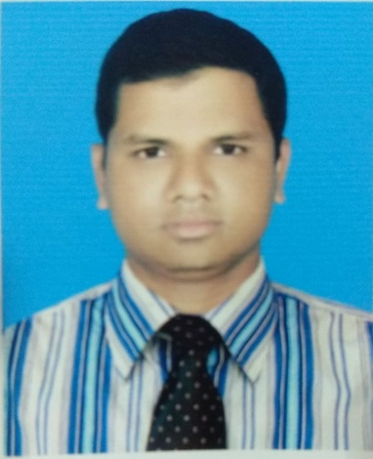
Resume
of
Mohammad Ali

S/O : Md.Rahmat Ali
P.O : Amin Jute Mills
P.S : Baizid, Chittagong
E-mail : mohammad.ali@php.com
Cell : 01815-350541

Objective: To obtain a challenging position within any team environment, in order to utilize my skills, desire and knowledge for establishing the efficient productivity.

Academic qualification:
Course Name : MBS (Accounting)
Result : 1st Class
Board/University: National University
Passing Year : 2013

Course Name : BBS (Accounting)
Result : 2nd Class
Board/University: National University
Passing Year : 2011

Course Name : H.S.C
Group : Business Study.
Result : GPA 3.70
Board : Chittagong

Course Name : S.S.C
Group : Business Study.
Result : GPA 3.56
Board : Chittagong

Computer Literacy:
Good at MS Word, MS Excel and able to operate conventional computer programs.
Work Experience:
- OfficerIndustrial Engineering department (IE)

Duration:01Years
Company:Regency garments limited, CEPZ, Chattagram.

- At present I am workingas a Accounts officer & Credit Controller at Corporate Office in Chittagong. In addition to this I have learnt about DSE, CSE, BSEC, Share trading system, CDBL etc
Duration: 2016 to till now
Company: PHP Stocks & Securities (PHP Family)
Language : Excellentin Bengali & English.
My strength : Like to take challenge and ensure the change.

HOBBY: Reading, Traveling, Enjoying music.
Personal Details:
Father’s Name : Md Rahmat Ali
Mother’s Name : Late Kamrunessa
Date of birth : 1st February 1987
Nationality : Bangladeshi by birth
Marital status : Married
Sex : male
Religion : Islam
Place of birth : Chittagong
Reference:
Name : Mr. Mohammed Jashim Uddin
Position : Assistant Manager
Institution : PHP Stocks & Securities Ltd
Address : PHP Centre, 40/1, South Kulshi, Zakir Hossain Road, Chittagong.
Phone : 031-632316
Mobile : 01678061040
Reference:
Name : Mr.Mohammad Nakib Alam
Position : CDBL In-Charge
Institution : PHP Stocks & Securities Ltd
Address : PHP Centre, 40/1, South Kulshi, Zakir Hossain Road, Chittagong.
Phone : 031-632316
Mobile : 01914-240898

Mohammad Ali

