INTRODUCTION
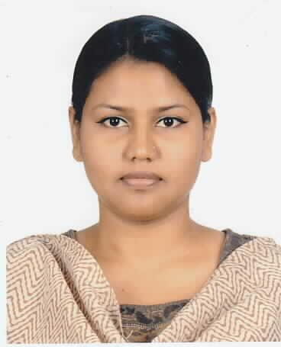
ANAMIKA HOQUE MUKTA
Present Address: House-216/2 Tejkuni para, Tejgaon, Dhaka-1215.
Mobile No. +88-01778846277 (imo, whatsApp),+88-01969660323 Email Address- ahmukta77@gmail.com

CAREER SUMMARY:
Opportunity to learn, take greater responsibility and serve the humanity.
PERSONAL DETAILS:
Father’s Name : Late Mozammal Hoque
Mother’s Name : Aleya Hoque
Date of Birth : 19th July’1979
Marital Status : Married
Nationality : Bangladeshi
Religion : Islam
Permanent Address : 216/2 Tejkuni para, Tejgaon, Dhaka – 1215.

ACADEMIC QUALIFICATION:
Exam | Group | Division/ Class | Board/ University | Year
S.S.C | Science | First | Dhaka | 1994
H.S.C | Humanities | Third | Dhaka | 1999
B.S.S | Social Science | Third | National University | 2003
M.S.S | Political Science | Third | National University | 2005

EXPERIENCE:
Farid Ahmed Bhuiyan Academi, from 15 July 2019 to Continuing
Instructor
# Company Location: Ramganj, Laksmipur.
# Department: School & College

Duties:
# Oversee everything from grade 6 to 12

Bangladesh Ansar & VDP, from 22nd June 1994 to 10th July 2013
Woman Sportsman (Karate-ka, Pistol Shooter)
# Company Location : Khilgaon, Dhaka
# Department : Training & Culture, Anasar Karate Team, Ansar VDP Shooting Club

EXTRA CURRICULAR ACTIVITIES:
Achievement on Karate:
National & Others Achievement on Karate:
- Bangladesh Marital Arts Association 93 (Gold medal)
- 10th National Karate Competition 93 (Gold medal)
- 11th National Karate Competition 94 (Gold medal)
- 2nd Quasem Group 96 (Gold medal)
- 6th Bangladesh Games 96 (Gold medal)
- 14th National Karate Competition 97 (Gold medal)
- 4th Quasem Group 98 (Gold medal) In 53KG
- 4th Quasem Group 98 (Gold medal) In Open
- 15th National Karate Competition 98 (Gold medal)
- Millennium Karate Competition 98 (Gold medal)
- City Karate Open National Competition 2000 (Gold medal) In +52KG
- City Karate Open National Competition 2000 (Gold medal) In Open
- City Karate Open National Competition 2000 (Gold medal) In Group Kata
- 7th Bangladesh Games 2002 (Gold medal)
- 17th National Karate Competition 2003 (Gold medal)
- 18th National Karate Competition 2004 (Gold medal)
International Achievement Karate:
- 8th SAF GAMES 99 (Kathmandu) Nepal (Bronze)
Achievement on National Shooting:
- 18th National Shooting Competition 2003, Bronze Medal in 10 Meter Air Pistol
- 21st National Shooting Competition 2007, Silver Medal in 25 Meter Sports Pistol
- 1st National Air Gun Competition 2008, Silver Medal 10 Meter Air Pistol
- 1st National Air Gun Competition 2008, Silver Medal 10 Meter Air Pistol Team
- 22nd National Shooting Competition 2008, Gold Medal in 10 Meter Air Pistol

__________________
Anamika Hoque Mukta

