TAREQUL ISLAM
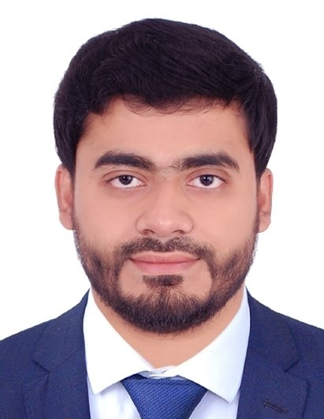

Masters in Information Technology (SUST)

DEWANERCHOK, SHAHPORAN, KHADIM NAGAR-3103, SYLHET,
BANGLADESH.

+8801771-516911

E-mail: info.tarequlislam@gmail.com

Profile

A dynamic and dedicated Computer Science & Engineering graduate. Well-versed in computer technology, IT & networking-related troubleshooting, and writing code to create systems that are reliable and user-friendly. Skilled leader who has the proven ability to motivate, educate, and manage a team of professionals to build software & web programs and effectively track changes. Confident communicator, strategic thinker, and innovative creator to develop Software & Website that is customized to meet a company’s organizational needs, highlight their core competencies, and further their success.

Academic Qualification

2023 Masters in Information Technology (MIT).
Shahjalal University of Science & Technology.
Result: Running

2022 Bachelor of Science in Computer Science & Engineering (CSE).
North East University Bangladesh.
Result: CGPA 3.09 out of 4.00
Passing Year: 2022

2015 Higher Secondary Certificate (HSC).
SAARC International College Bangladesh.
Board: Sylhet.
Group: Science.
Result: GPA 4.08 out of 5.00
Passing Year: 2015.

2013 Secondary School Certificate (SSC).
Jahiria M.U. High School.
Board: Sylhet.
Group: Science.
Result: GPA 5.00 out of 5.00
Passing Year: 2013.

Experience

1st February 2023 - Continuing
Assistant Teacher, Morning Sun Model School, Sylhet

Key Responsibilities: Classroom Instruction, Skill Development, Curriculum Development, Technology Integration, Assessment and Evaluation, Problem Solving, Digital Citizenship, Classroom Management, Assessment and Feedback, Individualized Support.

Special Skills

- Well known about computer operating, technology, IT & networking-related troubleshooting, programming, web development & software development.
- Good at in Computer programming, Web technology, Mathematics & ICT (Information & Communication Technology).

- Programming languages and mathematical packages: C, C ++, Python, JAVA, PHP, JavaScript, Calculus & Discrete Mathematics.
- Effective communication, management & supervision skill.
- Critical thinking skills; ability to address emergency situations and come up with effective solutions.
- Excellent time-management skills. Consistently maintain a high level of focus.
- Dedicated to the profession, regularly updates knowledge on new techniques, procedures, and the latest technology.
- Completed Digital literacy course for Youth.
- Ability to handle stressful situations, empathetic to the needs and concerns of students.

Language Proficiency


Bengali

English

Reading Writing Speaking

Extra-curricular Activity

Writing | Digital literacy | Cinematography
Presentation | Drawing | Illustration
Organizing | Decoration | Singing

Computer Basic Skills

- Office Program (MS word, MS Excel, Power Point).

- Network Browsing.

- Data Entry.

- Google App & Conference Call Management.
- Video Editing

Personal Details

Father’s name : Md. Rafiqul Islam

Mother’s name : Saleha Begum.
Permanent Address : Dewanerchok, Shahporan, Khadim Nagar-3103,
Sylhet, Bangladesh.
Date of Birth : 22th October, 1996.
Nationality : Bangladeshi.

Religion : Islam.

Marital Status : Married.
Gender : Male.

Blood Group : “O” Positive.

Reference

Shahadat Hussain Parvez Pranta Sarker
Assistant Professor Lecturer
Department Of C.S.E Department Of C.S.E
North East University Bangladesh North East University Bangladesh
Phone: +880 1723 807161 Phone: +880 1680 929776
E-mail: shparvez@neub.edu.bd E-mail: psarker@neub.edu.bd

Signature




Tarequl Islam

