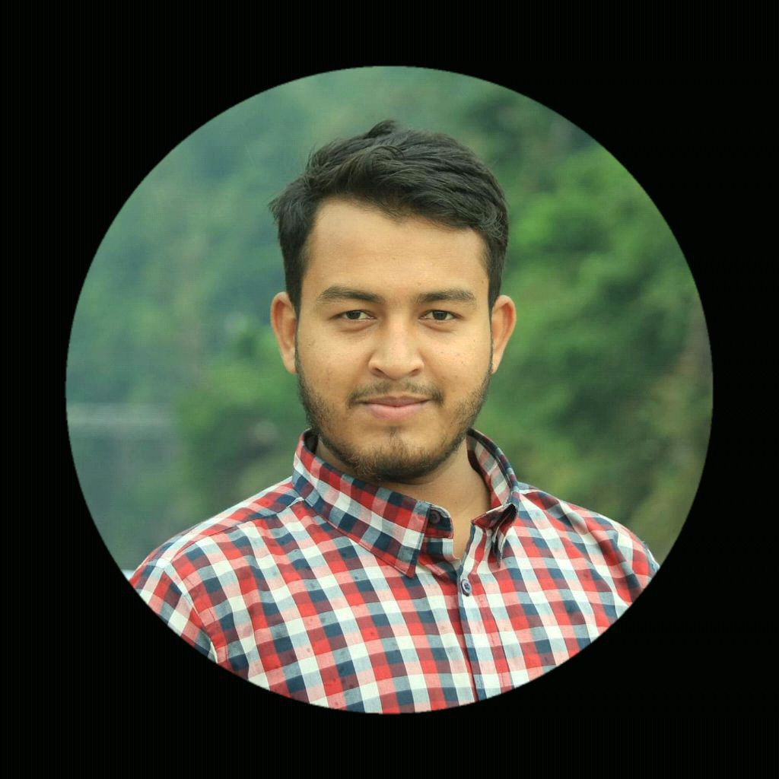  Sheikh Md.  Mehedi Hasan  Road:5,Block-G  Shajalal Uposhohor ,Sylhet  +8801770401502  mehedi.hasangp18996@gmail.com  I am student of hons 4th year department of Management. I am a self confident person. I have a good personality .  Spoken English – Intermediate  Microsoft word – Intermediate  Microsft Excel - Intermediate  Driving – Intermediate  Communicating skill–Intermediate | Still now I am a student. Because of that I have no  I have no experience . But I want to work heart and  soul and take more and more experience  I love walking, hiking and cycling.  I also enjoy crafting and I am an accomplished knitter.
  Contact
  objective
  Skills
  Work Experience
   | Education
  Exam Name |  |  | GPA
  Secondary school Certificate |  |  | 4.00
  Higher Secondary Certificate |  |  | 4.60
  Higher Education |  |  | Hons 4th
  Hobbies & interests

