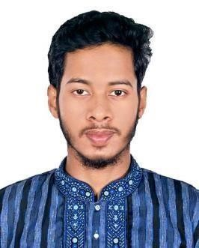
Curriculum Vitae Of Md Ashraful Islam

CONTACT ADDRESS
E-mail: ashrafulislam0120@gmail.com
Cell: 01610665862

CAREER OBJECTIVE

Creative, energetic, people oriented, and resourceful individual seeking opportunity to work as a skillful professional in organizational model where my educational background and others skills can be leveraged to augment organizational goals and objectives and enhance my professional experience.

CORE COMPETENCIES

Paid Social (Meta – Facebook & Instagram)
• Full-funnel campaign architecture (TOF–MOF–BOF)
• Advanced A/B testing & creative iteration frameworks
• Facebook Pixel & Conversion API (CAPI) implementation
• Retargeting and scaling funnels
• Custom & Lookalike audience engineering
• Performance-driven creative optimization
Google Ads (PPC)
• Search, Display & YouTube campaign management
• High-intent keyword research & match-type structuring
• Quality Score optimization & CTR improvement
• Smart & manual bidding strategy execution
• End-to-end conversion tracking & attribution
SEO & Organic Growth
• Technical SEO audits & site health optimization
• On-page SEO (content, metadata, internal linking)
• Authority-focused off-page link building
• Keyword & competitor intelligence
• Local SEO optimization for lead generation

PERSONAL DETAILS

Name | : MD. Ashraful Islam
Father’s Name | : Md. Noor Ahmed
Mother’s Name | : Saleha Begum
Date of Birth | : 15 September 2000
Gender | : Male
Religion | : Islam
Nationality | : Bangladesh (By birth)
Marital Status | : Unmarried
Present Address | : Turuk Khola, Daudpur, South Surma, Sylhet-3100
Permanent Address | : Lama doloi kandi, Gasbari, Kanaighat, Sylhet-3100
Blood Group | : B+ (Positive)
Contact No | : 01610665862
E-mail | : ashrafulislam0120@gmail.com

EDUCATIONAL QUALIFICATION

Institute | Passing Year | Group | Result | Board
S.S.C (Dakhil) | 2017 | Humanities | GPA- 4.10 | Madrasah
H.S.C (Alim) | 2019 | Humanities | GPA- 3.79 | Madrasah
BA (Fazil) | 2022 | BTIS | CGPA- 2.83 | IAU
Working Experience:

I am working as a reseller at Bbazar. And, I am also working as a Tour Opereator and Social Media Manager at TOGS (Travelers of Greater Sylhet)

I certify that information started in this CV is true and completed

................................... ...........................
Md. Ashraful Islam Date

