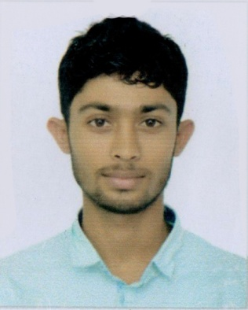
Curriculum vitae
Of
Santush Das
Cell: 01724427878
Email:santush586@gmail.com
Present address:
House:Prottoy-16, Roynogor,Sylhet
Permanent address:
Vill: Boushi, P.O: Boalia Bazar, Upazila: Nabigonj,Zila: Habigonj

Career Objective
To build up a career in a well-established and environment friendly organization where acquired knowledge and expertise can be used effectively and efficiently.
Self-Assessment
- A self-driven attitude, willingness to learn and a strong presence of mind.
- Optimistic, confident and benevolent.
- Energetic, devoted, sincere and hardworking.
Academic Qualification
Higher Secondary Certificate(H.S.C.)
Institution :Shacindra College
Board : Sylhet
Group : Humanities
Year of passing :2014
Result :5.00

Secondary School Certificate(S.S.C.)
Institution :Fakir Mohammed Adarsha High School
Board : Sylhet
Group : Humanities
Year of passing :2012
Result :4.38

BA (Hon’s):
Institution : M C College
Board : Sylhet
Group : Humanities
Year of passing : 2019
Result : 2.75(Approximately)

Computer Literacy
01. | Operating System | Windows 7,8 &10
02. | Word Processing | Microsoft Word
03. | Spread sheet analysis | Microsoft Excel
04. | Presentation | MS Powerpoint
05. | Special | Internet browsing,Graphics,Video editing

Personal Profile

Name : Santush Das

Father’s Name : Shyama Kanta Das

Mother’s Name : Sushanti Rani Das

Date of Birth : 02/08/1995

Blood Group : O+

Religion : Hinduism

Marital Status : Unmarried

Nationality : Bangladeshi

The information stated above is true

Signature

