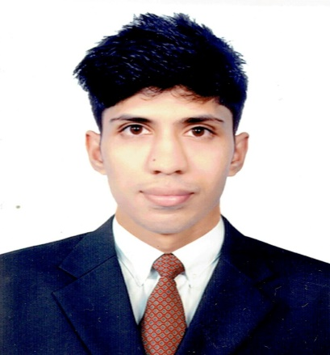
Resume
Of
Rahul Goph

Rahul Goph
12/A Nehari Para, Akhalia, Sylhet.
Mobile: +8801722318189
E-mail: rahulgoph6@gmail.com

CAREER OBJECTIVES

I am an ambitious and self-motivated individual that enjoys a challenge. I am extremely versatile and flexible in my approach and can adapt well to any ideas and concepts. I also enjoy participating in team meetings and events.
EDUCATIONAL QUALIFICATION

M.A in English
University : North East University Bangladesh, Telihaor, Sheikghat, Sylhet.
Result : Ongoing. (Final Thesis)
IELTS (International English Language Testing System)
Passing Year : July 2017
Result : 6 out of 9.
B.A (Hons.) in English
University : North East University Bangladesh, Telihaor, Sheikghat, Sylhet.
Passing Year : 2017
Result : 3.24 out of 4.00

Higher Secondary Certificate (H.S.C)
Group : Humanities
Passing Year : 2010
Result : 3.00 Out of 5.00
College : Moulvibazar Govt. College.
Board : Sylhet Board.

Secondary School Certificate (S.S.C)
Group : Humanities
Passing Year : 2008
Result : 3.38 Out of 5.00
School : Jagathpur High School
Board : Sylhet Board.

COMPUTER LITERACY

• MS word, MS Excel, MS Power point, Internet Browsing, Adobe Photoshop.

FIELDS OF INTEREST

- I enjoy listening to all types of Radio programs especially BBC and watching films. I have a keen interest in reading literature and meet different people.
COMMUNICATION SKILL

- Considerably modest user of English reading, listening, writing and speaking recognized by Cambridge University. Good at communicating with others, and participating in group and individual work.
- I am fluent enough in Bangla Language and can do communicate with others.
PERSONAL DETAILS
Certificate Name : Rahul Goph
Father’s Name : Deren Chandra Gosh
Mother’s Name : Sabita Rani Gosh
Mailing Address : 12/A Moriyom Bhobon, Nehari Para, Akhalia, Sylhet.
Permanent Address : Atghor, Nazirabad, Moulvibazar.
Date of Birth : 16-08-1992
Nationality : Bangladeshi by birth
Religion : Hindu
Marital Status : Unmarried
Sex : Male
Blood Group : B-(Neg)
REFERENCE

- Numan Ahmad
B.A (Hons.), MA in English (SUST)
Lecturer
Department of English,
North East University Bangladesh Sylhet.
Mobile: +8801710444615
E-mail: nahmad_77@yahoo.com

- Noruttom Das
BBA (SIU), MBA (NEUB)
Customer Relationship Officer
Consumer Division
IDLC Finance Limited
Mobile: +8801736608292
E-mail: noruttom@idlc.com

Signature:

Date: 08-01-2018

