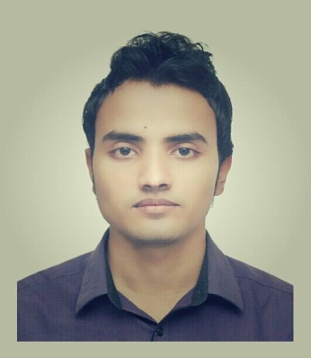
CURRICULUM VITAE
OF
Emran Hussen

Address: Sheker Goan, Singerkach, Bishwanath
Mobile: 01723338833
E-mail:Emran.lu.bba@Outlook.com

CAREER OBJECTIVE:
Looking for hard and Challenging Job where I will have the scope to utilize my potentiality, adaptability and skill to do something innovate and from where I will be able to enhance my knowledge.

Personal Details:
Name : Emran Hussen
Father’s Name : Md Dudu Miah
Mother’s Name : Azizun Nessa
Date of Birth : 01/01/1994
Nationality : Bangladeshi
Blood Group : B+
Marital Status : Single
Permanent address : Vill.Sheker Goan P.O. Singerkach : P.S.Bishwanath District.Sylhet

Educational Background:
Degree : Bachelor of Business Administration
Result : CGPA 2.74
Institution : Leading University Sylhet
Passing Year : 2013 held on 2017

Degree : HSC
Result : GPA 4.60
Institution : Blue Bird School & College Sylhet
Board : Sylhet
Passing Year : 2012

Degree : SSC
Result : GPA 3.63
Institution : Singerkach M/L High School
Board : Sylhet
Passing Year : 2010

Internship Training:
Three Month Internship training in “National Bank Limited” Bishwanath Branch.Sylhet

Membership:
President of Shopnotori foundation Sylhet
Former Founder President Red Green Friends Society, Singerkach Bazaar
Member of Leading University Social Services Club Sylhet

Language Proficiency:
Bengali: Excellent in speaking, reading and writing
English: Excellent in speaking, reading and writing

Computer Skills:
Computer Hardware, MS. Office & Internet Browsing

Interest:
Reading novel and Humorous Story, Traveling, Watching Movies, Enjoying Music and Sports

Strength:
Hard working
Self-motivated, Enthusiastic and Punctual
Dynamic and creative in thinking
Sense of good organizational behavior

References:
Shahedul Alam Shuvo  Senior Lecturer  Leading University Sylhet  Mob : 8801670565548 | Seram Atia Akash  Junior Officer  National Bank Ltd Bishwanth Branch  Mob : 01917986500

Signature

(Emran Hussen )

