Md.Abu Royhan 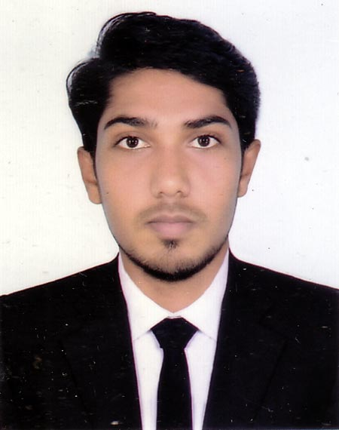
Cell: 01820994941
E-mail:raihan.yahoo999@gmail.com

Mailing Address:

House # 10, Patira Bazar,Talna,Khilkhat, Dhaka -1229

Career Objective:

Looking for a job where there is an opportunity to apply knowledge to pursue a professional career in a reputed dynamic organization that provides an excellent job environment for career growth and practices a professional performance culture where quality is recognized and rewarded.

Educational Qualification:

Secondary School Certificate (S.S.C.)
Institution : Dhanshail High School
Group : Humanities
Board : Dhaka
Passing Year : 2010
Result : G.P.A- 3.50

Higher Secondary School Certificate (H.S.C.)
Institution :B.A.F Shaheen College,Tejgaon (1051)
Group : Humanities
Board : Dhaka
Passing Year : 2012
Result : G.P.A- 3.00

Bachelor of Arts (Honos) (BA in English)
Institution : Southeast University
Major : English
Passing Year : 2016
Result : G.P.A- 3.32

M.A. (Master’s) in English
Institution : Southeast University
Major : English
Passing Year : 2018
Result : G.P.A- 3.18

Computer Skills:

- Office Application (Ms. Word, Ms. Excel, Ms. Power Point, Ms. Access)
- Internet Browsing, E-mail. Experience:
- Software: Graphics & Web Design (Illustrator & Photoshop)

Duties and Responsibility

- Ability to learn quickly and work under pressure.
- Work in a team environment and in critical situations.
Language Proficiency:
- Bengali: Fluent in both oral and written form.
- English: Well in both oral and written form.
Personal Skills:

- Excellent verbal and written communication skills both in Bengali and English.
- Ability to deal with people diplomatically.
- Fast learner, Team Facilitator.
- As an individual, I consider myself conscientious, honest and Frank.

Strengths:

- Like to face new people and environment.
- Hard working habit, self driven and change oriented.
- Strong communication and interpersonal skill.
- Sharp sense of social responsibility.
Personal Information:

Father's Name : Md. Piar Ali
Mother's Name : Ruksana
Date of Birth : 05/06/1993
Nationality : Bangladeshi
Religion : Islam
Marital Status : Unmarried
Sex : Male
Blood Group : B^{+ve}
Height : 5 feet 9 inches
Weight : 65 Kgs.
Permanent Address: :Vill: Deflai, P.O: Rangtiya,
P.S: Jhinaigati, Dist-Sherpur, Dhaka
Certification:

I, the undersigned certify that to the best of knowledge and belief that curriculum vitiate correctly experience. I understand that will fulfill misstatement described here in may lead to pay disqualification dismissal, if employed.

___________
Md.Abu Royhan
Date:

