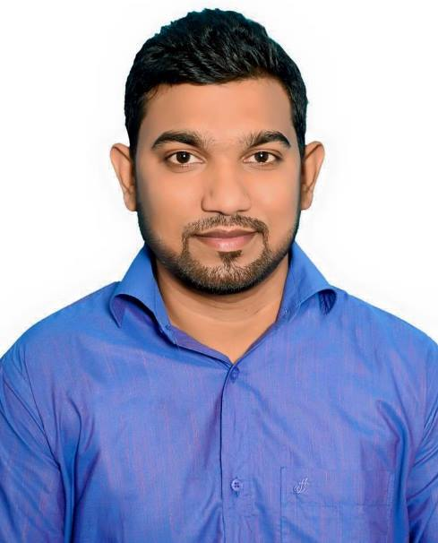

Curriculum Vitae
Of
Jamil Hussain

Contact

Cell: +880 1950225663
E-mail: jamil7953@gmail.com
175/5,promukta,bagbari, Sylhet

ABOUT ME

I am a self motivated person and believe in hard work, integrity, perseverance
and dedication towards the work on my hard advancement through
explanation to newly acquired knowledge in future .
CAREER OBJECTIVE

To increase my knowledge, experience, aptitudes and capacities within a
company, in order to grow as a better person and professional as well as take
challenges.
ACADEMIC QUALIFICATIONS QUALIFICATIONS

2017: Bachelor of Computer Science Engineering(CSE)
Sylhet Internationl University
CGPA –2.91 out of 4
2012: Higher Secondary Certificate (HSC)
Jalalabad College, Sylhet.
Sylhet Board
GPA- 3.91 out of 5
Group: Science
2010: Secondary School Certificate(SSC)
Fakira bazar high school, Barlekha,Moulovibazar
Sylhet Board.
GPA- 4.25 out of 5
Group: Science
LANGUAGE PROFICIENCY

Language | Speaking | Writing | Reading | Listening
English | Very good | Very good | Average | Average
Bangla | native

INTERESTS AND ACTIVITIES
Traveling,Reading, Listening , Public relation etc.
COUMPUR SKILLS

MS OFFICE | PHOTOSHOP | HTML,CSS | BOOTSTRAP | DESIGN
SOFTWARE MAINTENANCE |  | TYPING | PROGRAMMING | DATABASE

PERSONAL INFORMATION

Name  Father’s Name  Mother’s Name  Permanent Address  Present Address  Sex  Date of Birth  Nationality  Religion  Height  Blood Group  Marital Status  NID  Passport  Mobile Number  Email | : Jamil Hussain  : Md. Gias Uddin  : Chanara Begum  : Vill: Shatpur, P.O: Borni,  P.S:Berlekha, Dist: Moulovibazar.  : #175/1, Norshingtila, Bagbari, Sylhet  3100.  : Male  : 5th January 1993  : Bangladeshi by birth  : Muslim  : 5 feets 10 Inches.  : O +ve  : Unmarried  : 19935811415000084  : BR0045608  : +8801950225663  : jamil7953@gmail.com

Signature
jamil hussain

