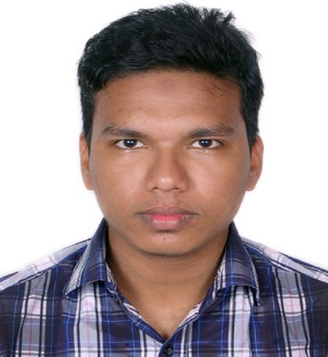


Mahbub Rahman

Software Developer

PERSONAL DETAILS

Date of birth : 02, November 1995

Address : 74/D, Sobuj Sena, Ghashitula, Sylhet

Mobile : +8801759034666
E-mail : Mahbub.shuvo10@gmail.com
Linkedln : https://www.linkedin.com/in/mahbub-rahman-7356a813b/

INTRODUCTION
I am a full stack software developer mainly working on backend with PHP. I have good experience with Laravel and Vue.js . I have 1+ years of working experience with Laravel and obviously, my love is Laravel. I want to build my future career on it.

EDUCATION

2014-2017 B.Sc. Engg. in Computer Science and Engineering
Metropolitan University Sylhet

2011-2013 Higher Secondary Certificate (HSC) Jalalabad College Sylhet

2009-2011 Secondary School Certificate (SSC)
The Aided High School, Sylhet

TRAINING

- Higher Diploma in Computer Science and Engineering
National Youth Development Training Center , Sylhet
July 2013 – Jun 2014
- Higher Top-up IT Training
Bangladesh Computer Council (BCC)
August 2017 – February 2018

EXPERIENCE

Panacea - IT
Web developer
March 2018 - August 2018

SKILLS

HTML & CSS
MySql
PHP
Laravel
JavaScript
Vue.js

RESTful API
Git

ACHIEVEMENTS

- 2nd runner-up in a project showcasing at Metropolitan University Tech Fest 2017
- Got junior programmer award from Metropolitan University Programming Contest in 2015
- Got Prize in Indoor Game Championship from Jalalabad College

EXTRA CARICULAM ACTIVITIES

- Voluntary Work
    - Future Of Web Development -with 'Jhankar Mahbub'
    - Workshop on Front-end Web Development 2017

LANGUAGE PROFICIENCY

- Speaking and writing fluently both in English and Bengali.
- Good in writing and experienced in research.

