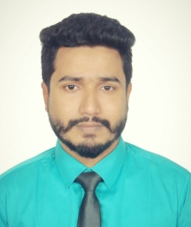

WORK EXPERIENCE

01-09-2016 to 01-09-18

MD. A.K. KHAN RAIHAN

Hatirthan, Katiyadi Bazar, Moshajan, Habiganj sadar, Habiganj (Bangladesh)
+8801719349894

Raihankhan21@gmail.com Skype Raihan.khan46
Sex Male | Date of birth 18-08-1992 | Nationality Bangladeshi

China Garden,DhakaBangladesh
Position: Senior Executive Account Officer Responsibilities:

Keeping daily transactions Managing budgets
Maintaining statistical and financial record Handling customer complaints and queries Promoting and marketing business

03-05-2016 to 20-06-2016 Internship
Islami Bank Bangladesh Limited, Sylhet (Bangladesh) General banking:
Opening bank account
Term deposit open Investment
Cheque issue to the customer Foreign remittance

EDUCATION AND TRAINING

01-03-2012 29-08-2016 Bachelor of Business Administration
Sylhet International University, Sylhet (Bangladesh) Major in Accounting.

01-07-2009–27-07-2011 Higher Secondary Certificate Examination.
Brindaban Govt. College, Habiganj (Bangladesh)

01-01-2007–26-05-2009 Secondary School Certificate Examination
J. K & H. K High school,, Habiganj (Bangladesh)

28-01-2014 30-01-2014 Community Level Volunteer Training Programme
Fire service and Civil Defence, Sylhet (Bangladesh)
- Learn about Leadership, Fire fighting and rescue, First Aid, Discipline.
- Trained as a second line Army.
- Trained How to survive any critical situation.
- Trained how to manage people and behave with them.
- What the responsibility as a leader.

01-08-2015 30-08-2016

Language Proficiency

Certification:
Volunteer
Proactive BD, Sylhet (Bangladesh)
Involved with so many community developments interface considering Health and Hygiene, Education, IT and Innovation, Soft Skill development, Life style enhancement.

IELTS Overall: 6.0

I undersigned certify that, to the best of my knowledge and belief, this curriculum vitae correctly describe myself, my qualification. I understand that wilful miss statement describe here in may lead to my disqualification.

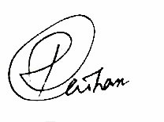

.......................................

Md. A. K khan Raihan

