CURRICULUM VITAE
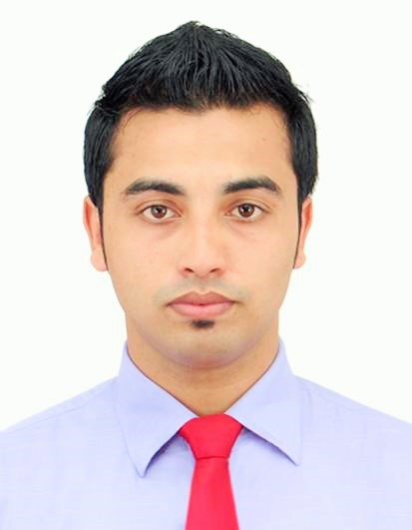

Abu Sayed
75 Rukon Monzil-2
Vatalia,Sylhet
Mobile : 01715379241
E-mail : md.abusayed5914@gmail.com

Profile:
Love to work hard and always passionate about the works. Have a dynamic vision and flawless mind to prove my determination towards any field of work. Career oriented and looking to leverage my knowledge and expertise in Professional Universe.

Educational Qualification:
Exam | Year | Institution | Grade
BSc in CSE | Final Year (Doing My Final Year Project) | Metropolitan University ,Sylhet | 3.05
HSC | 2013 | M.C Academy School & College ,Sylhet | 4.50
SSC | 2011 | Golapgonj Jamia Islamia High School | 4.31

Language Competency:
- Bangla
- English (Average)
Skills:
- Data Entry
- Microsoft Office
- Virtual Assistant
- Lead Generation
- Telemarketing
- Internet Research
- HTML
- CSS
- Bootstrap
Personal Details:

Full Name : Md. Abu Sayed
Father’s Name : Abul Hasan
Mother’s Name : Halima Begum
Date of Birth : 25-08-1994
Gender : Male
Marital Status : Unmarried
Nationality : Bangladeshi

