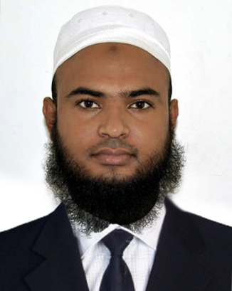

Anamul Haque

Address : 190/A, Khazol Sha , Sylhet.
Mobile : 01733-384114
Email: ahp3338@gmail.com

Career Objectives
Looking for a position in an organization that will help to utilize my academic fitness, capabilities, experiences and build up my career.
Key Strength
- Good in oral and written communication.
- Ability to manage people and resources.
- Self-motivated with excellent interpersonal skills.
- Ability to work with colleagues or partners of all levels.
- Capable of doing job under pressure.
- Quick learner.
Computer Experience:
- I have 10 years experience. I can do any work. Online Marketing, E-mail Marketing, Ms Word, Ms Excel, Ms Power-point, Internet Operating etc others Adobe Photoshop, Adobe Illustrator & Software Installation.
Duties/Responsibilities:
- Take the Reservation by Phone & Mail.
- Guest Check In & Check Out
- Manage customer by providing product information etc.
- Night Audit
- Knowledge about NICE Software.
EDUCATIONAL QUALIFICATION:
Honors
- Education Institute : Leading University, Sylhet
- Subject : English
- Year : 2nd (Study off)
Higher Secondary Certificate (H.S.C)
- Institute : Derai Degree College
- Group : Humanities
- Result : GPA- 3.08 out of 5.00
- Passing Year : 2015
Secondary School Certificate (S.S.C)
- Institute : Boolchand High School
- Group : Humanities
- Result : GPA- 2.69 out of 5.00
- Passing Year : 2013

PERSONAL DETAILS:
Name : Anamul Haque
Father’s Name : Abdul Sattar
Mother’s Name : Juthsna Begum
Date& Place of Birth : 20th November, 1997
Religion : Islam
Nationality : Bangladeshi (By Birth)
Marital Status : Unmarried
Blood Group : B Positive
Bike : Fazer 2015
Permanent Address : Vill : Dhapkai, P.O : Haranagar, P.S : Derai, Dist : Sunamganj.

Hobbies & Interests

- Reading Books, & listening music, Enjoying Movie, Traveling, Browsing Internet & Discovering innovative things.

References

  - Muhammad Nazrul Islam
Assistant Professor
Department of Head (English)
Leading University, Sylhet.
Cell: +88 01717-326505
E-mail: nazrul@lus.ac.bd

- Dr. Hasnat Anwar
MS (Otolaryngology & Head-Neck Surgery) Phase –B, Resident
Sylhet M.A.G Osmani Medical College
Mobile : 01710-437247
E-mail: hasnatsh@gmail.com

Declaration

I hereby declare that the information furnished above is true to the best of my knowledge. I do hereby declare that above particulars of information and facts stated are true, correct and complete to the best of my knowledge and belief.

Anamul Haque

