RESUME

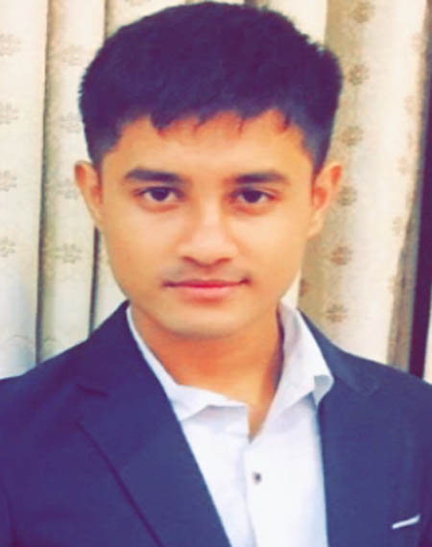

of
Sayed Ali Noor Haque
Flat: SB/3, Building Name: Karobi, Lake City Concord
Khilkhet, Dhaka-1229
E-mail: alinurashik71@gmail.com
Mobile: +88-01303970655,+8801869702601

Career Objective: Looking for challenging job where scope to innovate something by utilizing my full potential skills and where I will be able to share knowledge to enhance my skills an ability and some expertise in me.

Educational Qualifications:
- Bachelor of Science in Computer Science and Engineering (CSE)
Institution : American International University-Bangladesh (AIUB)
Graduation : Appearing
CGPA : Appearing

- H.S.C (Higher Secondary Certificate):
Institution : Cambrian School and College
Group : Science
GPA : 5.00 (On a 5.00 point scale)
Board : Dhaka
Passing Year : 2016

- S.S.C (Secondary School Certificate):
Institution : Cambrian School and College
Group : Science
GPA : 5.00 (On a 5.00 point scale)
Board : Dhaka
Passing Year : 2014

- J.S.C (Junior School Certificate):
Institution : Cambrian School and College
GPA : 5.00 (On a 5.00 point scale)
Board : Dhaka
Passing Year : 2011

Experience:

- Position: Home Tutior (Right Now)
[English and Science Related Subject:5 to 12]

- Company: BSB Global Network,Gulsan, Dhaka.
- Position:Counselor
[Less than one year :2018]

- Position: Salesman ( In Zharki Fashion, Khilkhet, Dhaka)
[Less than one year :2017]

Personal Assessments:
* I always hold a positive attitude toward talking challenging initiatives.
* Hard working ability in diver’s environment and with a dynamic work group.
* I always welcome relation views and perspective.
* Able to adapt in new environment.
* Be honest
Computer Skill:
Operating System : Windows 7, Windows xp, Windows 10.
Office application : Excel and PowerPoint, SQL,Net browsing.
Programming languages: C, C++, Java, .

Interests and hobbies:
- Volunteer work
- Travelling, fishing
- Club membership, Hospitality,Music

Personal Information:
Name : Sayed Ali Noor Haque
Nick Name : Ashik
Father’s Name : Sayed Anamul Haque
Mother’s Name : Nurjahan Begum
Date of Birth : 01 November 1998
Blood Group : O (+ve)
Height : 5’.8”
Religion : Islam
Marital Status : Single
Nationality : Bangladeshi
National ID No : 7804712813
Present Address : Flat: SB/3, Building Name: Karobi, Lake City Concord,
Khilkhet, Dhaka-1229

Language proficiency:
Good command over English and Bengali.

Sayed Ali Noor
Signature

