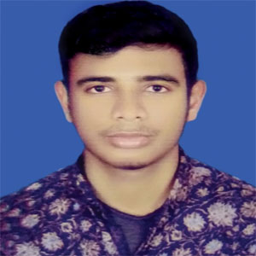
RESUME
OF
Md.Faruk Hosen
Cell: 01304053149

CAREER OBJECTIVE:
I want to take the challenge of job hazard. I would like to welcome the change to work as a part of dynamic working team where I believe that I could make a significant contribution while developing my skills yet future.

ACADEMIC QUALIFICATION:

- Secondary School Certificate(S.S.C)
School Name :Kashipur M/L High School
Group : Science
Passing year : 2017
Division/Grade : 4.27(GPA)

LANGUAGE PROFICIENCY:
Native language in Bengali, well proficiency of speaking, reading, writing and listening to English.

COMPUTER LITERACY:
Adequate knowledge in MS. Word, MS. Excel, Access, Basic computer operating, Type Bengali and English.

CAPABILITIES:
As honest, Self-motivation and hard working, Efficient and responsible person. Able to work and maintain relations with on all levels.

PERSONAL DETAIL’S:

Name : Md.Faruk Hosen
Father’s Name : Md.Jalal Uddin
Mother Name : Mst.Farida Begum
Permanent Address : Vill : Dhormopur
P/O : Gongerhat
P/S : Fulbari
Dist : kurigram.

Present Address : Bilaspur,Joydebpur,Gazipur.
Contact No : 01304053149
Home Mob. No : 01404824281
Date of Birth : 01/01/2000
Religion : Islam
Nationality : Bangladeshi (By Birth)
Marital status : Unmarried
Sex : male
Home District : kurigram

Md.Faruk Hosen

