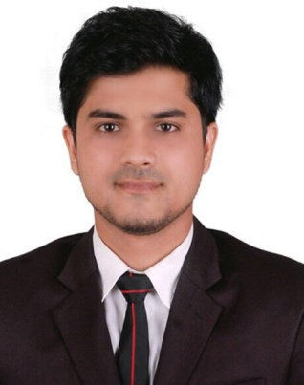

Ehsan Ahmed Chy.
24/2, Jaygirdarbari, Khasdobir, Amborkhana, Sylhet
Cell: +8801732-723961
E-mail: ehsanrobin07@gmail.com

CAREER OBJECTIVE:

To work in challenging environment, achieve skills in the respective field and work for the simultaneous progression of organization and myself.

ACADEMIC QUALIFICATIONS:

Exam Title | Concentration/Major | Institute | Result | Passing Year
BBA | Marketing | Leading University, Sylhet. | CGPA: 3.32  Out of 4 | 2015
HSC | Humanities | Jalalabad Cantonment Public School & College. | GPA: 4.60  Out of 5 | 2009
SSC | Humanities | Ranaping Adarsha High School. | GPA: 3.81  Out of 5 | 2007

EMPLOYMENT HISTORY:

Designation | Organization | Department | Duration
In-Charge | Hotel Noorjahan Grand,  Dargah Gate, Sylhet. | Front Office | 1st September 2017 - Continuing
Front Office Executive | Hotel Noorjahan Grand,  Dargah Gate, Sylhet. | Front Office | 20th August 2016- 31st August 2017
Intern | First Security Islami Bank Ltd.  Sylhet Branch. | General Banking | 15th October 2015- 14th January 2016

COMPUTER LITERACY:

Course: Diploma in “Information & Communication Technology” (ICT).
Duration: 26th April, 2016 - 14th November, 2016 (06 months).
Institute: Bangladesh Computer Council (BCC), Sylhet Regional Office.
Course Covered: MS Office, Hardware & Troubleshooting, Graphics Design, C Programming, Computer Networking, and Web Development (HTML, CSS, and PHP).

LANGUAGE PROFICIENCIES:

Language | Reading | Listening | Writing | Speaking
Bengali | High | High | High | High
English | High | High | High | High

KEY PERSONAL FEATURES:

- Strong desire and willingness to take new challenges of designed responsibility.
- Ambitious and Self-Motivated person a flexible with an ability to acclimatize environments.
- Capable to work with multicultural people.
- Ability to Lead.

PERSONAL INFORMATION :

Name : Ehsan Ahmed Chy.
Father’s Name : Ekhlas Ahmed Chy.
Mother’s Name : Asma Begum
Date of Birth : 26th October 1992
Religion : Islam.
Nationality : Bangladeshi. (By birth)
National ID : 19929113851000081
Marital Status : Unmarried.
Blood Group : O+
Height : 5 feet 9 inch.
Present address : 24/2 Jaygirdarbari, Khasdobir, Borobazar, Amborkhana, Sylhet.
Permanent address : Vill: Chondonbag, P.O: Ranaping- 3163, P.S: Golapgonj, Sylhet.

REFERENCES :

Md. Hasan Murshed  Chief Advisor & General Manager,  Hotel Noorjahan Grand, Sylhet.  Mobile: +8801748-973615  Email: hasan_murshed@hotmail.com | Tanvir Ahmed Torophder  Assistant Secretary,  Ministry of Foreign Affairs  Governments of the People’s Republic of Bangladesh.  Mobile: +8801711-026212  Email: tanvitaj39@yahoo.com

ACKNOWLEDGEMENT :

I hereby declare that the information given above is true and confirm that if there is any information goes wrong I will be treated as disqualified.
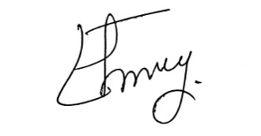

Ehsan Ahmed Chy.

