RESUME
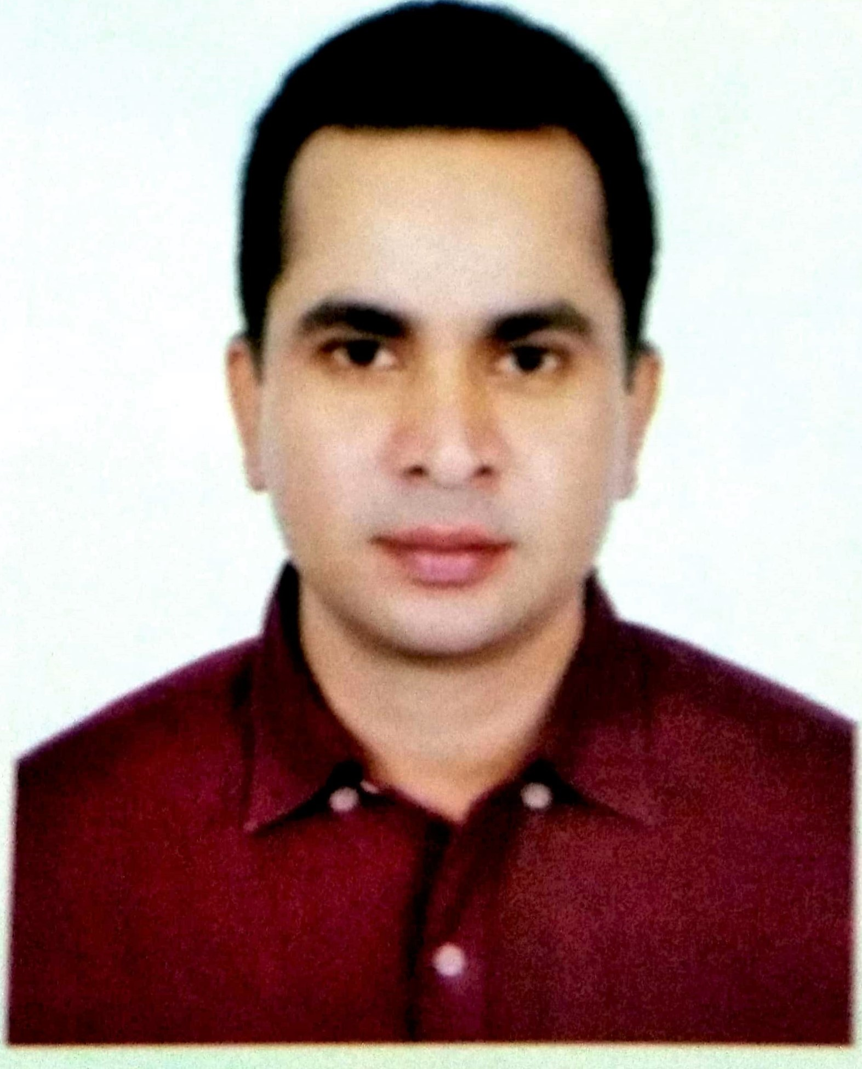
Picture
OF
MD.ABDUR RAZZAQUE HOSSAIN
Mob: 01720828466, 01871467795
1) Career Objective : Build up a in a challenging environment with excellent career development prospect, where hard work, strict discipline is the corner stone of success.
2)Contact Address :Present
Fakirbari, jamgora, Ashulia, Savar, Dhaka
Permanent Address:
Vill: Singdair, Post: Singdair
P.S: Nagarpur, Dist: Tangail

3) Personal Address :Father’s Name :MD.Nilchand Miah
Mother’s Name :Sabia Khatun
Date of Birth :1th January 1984
Marital Status :Married
Nationality :Bangladeshi (By birth)
Religion :Islam
4) Educational Qualification S.S.C
Passing Year :2001
Result :G.P.A 3.00
Institution :Taluknagar High School
Board :Dhaka
H.S.C
Passing Year :2003
Result :G.P.A . 2.40
Institution :Govt.Nagarpur College
Board :Dhaka
5) Special Interest : Watching different games, documentary English movies and studying literature, history

6) Job Experience :Since 10th December 2016 to till now I was working with B.S Fashion A house of Quality Bangladesh Office House No#502,Road# 9, Baridhara DOHS, Dhaka-1206. As Quality Assurance

Since 10th January 2012 to 30 November 2016. I was working with Norp Knit Industries Ltd. Islampur, Nawzor, Gazipur. As Q.A

Since 12th November 2005 to 30th December 2011.I was working with Palmal Group. Jamgora, Ashulia, Savar, Dhaka. As Quality In-charge

Since 5th January 2002 to 30th October 2005. I was working with Beximco Group. Chakroborty, Kashempur, Gazipur. As Q.I & Quality Controller

7) Computer Experience : (a) Microsoft Word (b) Excel (c) Access
(d) Power Point (e) Photoshop
8) Buyer’s Name Gap, Wal-Mart, George, B.Young, Rip curl, Oxbow Long Board, Mangum, Adler, Kufhof, Canada sportswear ltd, Nordstrom, Group Go Sport, Trafiq Dristry Center, H&M, Zara Man, Tamnoon, C&A, Spider man, Etc.

Date: 29/09/2019. MD.Abdur Razzaque Hossain.

