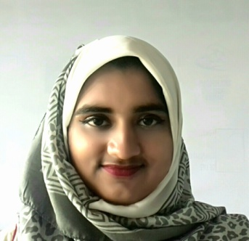
Fawzia Binta Faruque

Email : fawziabintafaruque@gmail.com
Phone no : +8801757518804
Address : ShariatMonjil, KumargaonTrimukhi, Sylhet

I am a talented, bright and self-disciplined student who wants to enlighten her life with her work. I also love to communicate with people and know them.

EDUCATION:
Bachelor of Science (Engineering):
Institution : Shahjalal University of Science and Technology, Sylhet
Department : Petroleum and Mining Engineering
Session : 2015-16
Duration : January 2016 – December 18, 2019
CGPA : 2.92 out of 4 (up to 3rd year)

ACCOMPLISHMENT:
- Bronze winner at ‘Regional Taekwondo Competition 2014’
- Second Runner-up of wall magazine presentation in ‘Annual Cultural Competition 2014’
- Most Prominent Organizer of ‘12th Intra SUDS Debate League ’16’
- Accomplished competitor of ‘University Physics Competition 2017’
- Winner of ISCEA Business Case-solving competition 2017
- Organizer of ‘PME Day- Reunion & 12 Year Celebration’
- Champion of ‘13th Intra SUDS Debate Championship ’17’
- Champion of ‘14th Intra SUDS Debate Championship ’17’
- Champion of ‘15th SUDS Inter-department Debate Competition 2017’
- Champion of ‘16th SUDS Inter-department Debate Competition 2018’
- Champion at ‘Science Fiction Story Writing Competition’ of ‘SSA Inter University Science and Technology Festival 2019’
- Second Runner-up at ‘IQ Test’ of ‘SSA Inter University Science and Technology Festival 2019’
- Champion at ‘ActionAid- Prothom Alo Bondhushova National Debate Festival 2019( Sylhet Devision)’

ORGANIZATION:
- SUST SPE Student Chapter:
Publication Secretary (January 2018-Present)
Co-Executive Member (March 2017-January 2018)
- Shahjalal University Debating Society:
Debater (February 2016- Present)
Organizer (February 2016- Present)
Treasurer (March 2019- Present)
Publication Secretary (May 2018- March 2019)
Assistant Publication Secretary (June 2017- May 2018)

- KIN (A Voluntary Organization):
Teacher (February 2016- November 2016)
- PME Association:
Executive Committee Member (April 2016- October 2017)

SKILL:
  - CERTIFICATION:
    - Certified supply chain analyst from August 2017
    - Training on ‘Industrial Process Unit Operation & Process Control Technique’

  - TECHNICAL SKILL:
- Completed course on MS Word, MS powerpoint, MS Excel and C programming.
- Programming language: c, c++.
- Have skill in Photoshop.

  - LANGUAGE SKILL:
    - Have Fluency in English writing and somewhat moderate speaking skill.

  - OTHER:
    - I’m dedicated and committed to my work and a fast learner. Always tries to complete the assigned project within deadline.
    - Have good communication skills in both vocal and writing form of communication. Always tries to present my opinion in a modest and presentable way.

