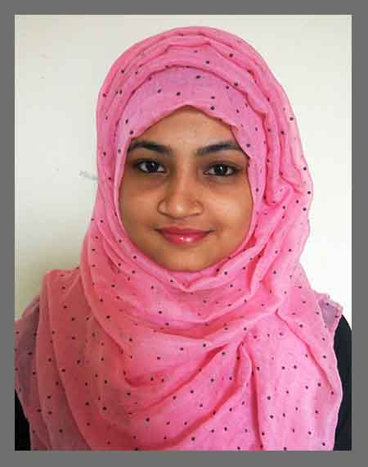
Helena Akter
Cell phone number.: +88 01768988053
Address: 35/A, Samim Ahmed, Zollarpar, Sylhet 3100

Career Objective

To build up a career that is not merely a means of living but rather means for making life meaningful. To work in an organization which offers a competitive & performance based environment and nourish the talents and explores inherent abilities for the development of the organization.

Self Assessment

I am sincere, honest, hard working, pragmatically challenging, self-motivated and reasonably presentable person having positive attitude towards with good interpersonal relations with different national religions.

Educational Qualification

- Higher Secondary School Certificate (HSC)
Background: Science Passing year: 2013
GPA: 3.60 (5)
Scholarshome Girl’s College, Sylhet

- Secondary School Certificate (SSC)
Background: Science Passing year: 2011
GPA: 4.63 (5)
Chandranath Girl’s High School, Chatak
Computer Skills

MS Office Suite: Word, Excel, Power point
Web surfing & Internet browsing

Language Skills

Proficient user of both English & Bengali

Personal Information

Name: Helena Akter Baby
Father’s Name: Haji Md. Rouf Miah
Mother’s Name: Mst. Nurjahan Begum
Address: 35/A, Samim Ahmed, Zollarpar, Sylhet 3100
Date of Birth: 05/12/1995
Gender: Female
Nationality: Bangladeshi
Relationship Status: Single
Religious Belief: Islam

I do hereby certify that the above particulars furnished by me are true and correct to the best of my knowledge.

……………………………………
Helena Akter

