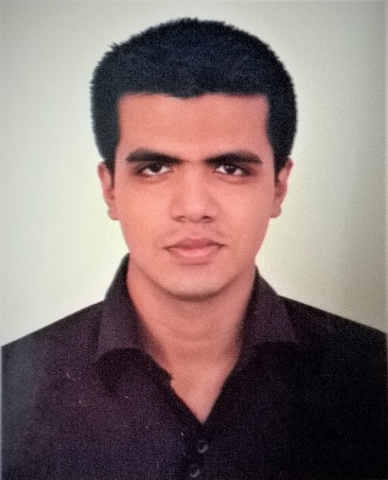
SK Sabbir Ahmed
Shahid Sergeant Zahurul Haque Hall, University of Dhaka
Mobile: 01864454215
sksabbirahmed.bd@gmail.com

Career Objective:
To pursue a highly rewarding career, doing a job in challenging and healthy work environment where I am safe and I can utilize my skills and knowledge efficiently for organizational growth.
Profile: A student. Young and highly motivated individual. Pro-active, practical and oriented to problem solving even under stressed circumstances.
Experiences:
- Academic writing, Professional writing, worked as a research assistant with a professor of English.
- Campus ambassador (University of Dhaka) at Excellence Bangladesh
3. Foreign tourists guiding
4. Volunteered in many programs including Bangladesh English Language .. Teachers Associations (BELTA); Regional programs under UN.
5. Scouting (APL), Revering (Senior Rover Mate), Attending two national . .. jamboore and many other camps.
6. Debating, Drama.
- Former Class representative.
- Teaching English SSC, HSC, Public university admission seekers along with O level students.

Education:
Program: Bachelor of Arts in English (4th year; final Semester Running)
Institution: University of Dhaka
H.S.C.
Institution: Rangdia School and College
Board: Jessore
Group: Humanities
Result: Grade Point Average 5 (A+)
Year of Passing: 2016
S.S.C.
Institution: Rangdia School and College
Board: Jessore
Group: Humanities
Result: Grade Point Average 5 ( A+)
Year of Passing: 2014
Lingual Capability:
Bangla: Mother Tongue
English: Fluent in speaking and all other skills
Spanish: Apprentice

Computer literacy:-
Operating systems: windows XP, windows 7, windows 10.
Application tools: MS- Word, Power Point, Internet and Email.
Competence:
- Excellent communication skills in both verbal and writing.
- Leadership skills.
- Easy adaptation.
- Hardworking.
Personal Data:
Father’s Name: SK Afzal Hossain
Mother’s Name: Nargis Begum
Date of Birth: 26 March 1998
Permanent Address: Vill: Karticdia, Post: Karticdia,
Thana: Bagerhat, District: Bagerhat.
Sex: Male
Nationality: Bangladeshi
Religion: Islam
Marital Status: Single
Hobby:
Voluntary works, Reading Books, Traveling, Watching movies.
References: Available on request.

