CURRICULUM VITAE

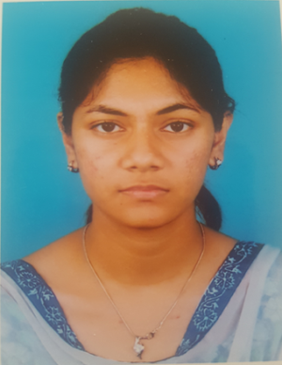
Azmeri Akter Nishi
C/O: Md. Nurul Alam Shiplu
House # W/H-11,
P.O -Ferozshah,
P.S - Akbarshah,
Dist-Chittagong - 4207.
Cell phone: +8801676963212
E-mail-azmeri93@gmail.com

Job Objective:

Seeking a responsible career opportunity in an organization that will best utilize my learning, realizations and where significant contribution to the success of the employee can be made and career advancement opportunities can be achieved.

Educational Qualification:

Post-Graduation: |  | Discipline | : LL.M.(Human Rights)
 |  | University | : Chittagong Independent University
 |  | Year | : 2019
 |  | G.P.A. | : 3.30
Graduation: |  | Discipline | : LL.B. Honors
 |  | University | : Southern University Bangladesh
 |  | Year | : 2016
 |  | G.P.A | : 2.95
Higher Secondary Certificate (H.S.C) |  | Institution | : Chittagong College
 |  | Year | : 2012
 |  | Group | :Humanities
 |  | GPA | :2.30

Secondary School Certificate (S.S.C.) |  | Institution | : Shere Bangla Balika MohaViddaloya
 |  | Year | : 2008
 |  | Group | : Humanities
 |  | GPA | : 4.00

Language Proficiency:

English | : Good skill both in written and oral.
Bangle | : Excellent ability both in speaking and written.
Computer Skills:
♣ | MS Word/ Excel
♣ | Internet Browsing

AREA OF EXPERTISE:

• Able to work constantly under time and resource constraints.
• Able to take responsibility in emergency situations.
• Can prioritize and handle multiple tasks while meeting established deadlines.
• Can ensure the proper evacuation procedures are in place in case of an emergency situation arising.
• Courteous and always focused on providing a consistently high standard of customer service.

Workshop Attend: Practice & Procedure in the family Court - Southern University Bangladesh

Personal Profile:
Father's Name | : | MD.Alauddin
Mother's Name | : | Yeasmin Khan
Date of Birth | : | 10thoct 1993
Gender | : | Female
Marital Status | : | Unmarried
Nationality | : | Bangladeshi
Religion | : | Islam
Hobby | : | Traveling , Reading Book , Listening Song

