CV of
MOJAMMAL HOSSAN
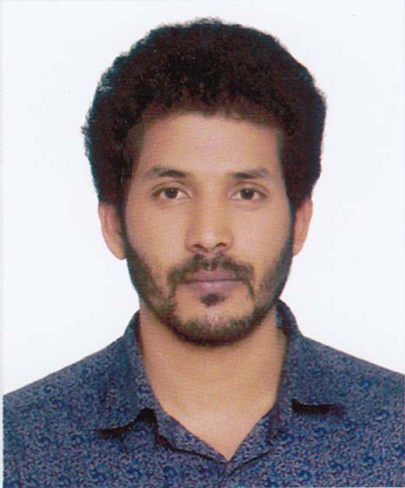

Career Objectives

I would like to develop my talents, to exercise my initiative, my creativity to its fullest, fully utilize my education and strengths to again wealth of enriching experience and to serve my people.

Personal information

Nick Name : Muzammil
Father’s Name : Md.Shirazul Islam
Mother’s Name : Hasna Ara Begum
Present Address : Vill: Krishi Farm. P.O: Islampur-3100, Dist: Sylhet
Parment Address : Vill: Krishi Farm. P.O: Islampur-3100, Dist: Sylhet
Date of Birth : 14 April 1994
Nationality : Bangladeshi
Religion : Islam
Sex : Male

Current Study:
Education Qualification

BSS (Pass)
Institution : MC College
University : National University of Bangladesh
Session : 2012-2013
Current Status: on going
Higher Secondary Certificate (H.S.C) in Business Study
Board : Sylhet
Result : GPA- 3.30
Passing year : 2012

Secondary School Certificate (S.S.C) in Science
Board : Sylhet
Result : GPA-3.44
Passing year : 2010

Career Objectives

Operating System: Windows 98, 2000 XP, Windows-7
Office Package: MS word, MS power point, MS Excel.
Good Typing Speed in English & Bangla.
Working Experience:

- Computer Operator at Sylhet Commerce Coaching Home for 3 years.
- Computer Operator at Women's Model College, Sylhet, form 15th October 2017 to till now.

I hereby, affirm that all statements made by me on this form are correct. I understand that any inaccuracy or false information will render my application invalid.

Sincerely yours,

______________

(Md. Mojammal hossan)

Date:

