CURRICULAM VITAE
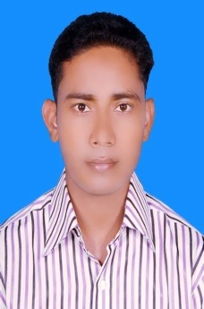

1. | Name | : | Md. Siddiqur Rahman
2. | Father's Name | : | Md. Sekander Ali
3. | Mother's Name | : | Aleya Begum
4. | Date of Birth | : | 01 March 1989
5. | Nationality | : | Bangladeshi by birth
6. | Address | : | Rongdhonu Residence, Airport Road, Post: Sylhet Cadet College, Sylhet.
7. | Educational profile | :

Exam name | Result | Board / University | Passing Year | Group
SSC | 4.88  out of 5.00 | Dhaka | 2011 | Science
HSC | 4.50  out of 5.00 | Dhaka | 2013 | Science
BBA | 2.87  out of 4.00 | National University | 2016 | Business Studies
Diploma in ICT | 4.00  out of 4.00 | Bangladesh Computer Council, ICT Ministry | 2018 | ICT

8. | Mobile Number | : | 01915-885550
9. | Mail Address | : | msrahman.net@gmail.com.

Faithfully yours

Md. Siddiqur Rahman
Date:11.11.2019

