AHMAD SIDDIQUE FORHAD | 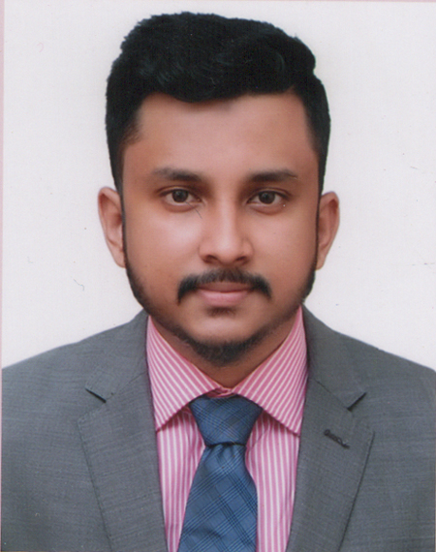
Address: House No. 12 Al Safa ,Patantula, Sylhet-3100.
Mobile : 01728073509
e-mail: forhadasf@gmail.com
Career Objective:
To seek a challenging profession in a competitive environment where my knowledge and ability can be enriched to yield the optimum benefit to the organization as well as myself.

Employment History:
Lafarge Surma Cement Ltd.
Internship at Lafarge Surma Cement Limited (Accounts Dept.), Chhatak ,Sunamgonj.
Academic Qualification:
- MBA Masters of Business Administration
Year: 2015
Department: Marketing
Class Obtained: 3.19
Institution: Sylhet International University, Sylhet, Bangladesh

- BBA Bachelor of Business Administration
Year: 2014
Department: Finance
Class obtained: 2.36 (2nd class)
Institution: Sylhet International University, Sylhet, Bangladesh.

- H.S.C Higher Secondary Certificate
Year: 2009
Group: Business Studies
Board: Sylhet
Grade: 3.30
Institution: Madan Muhan College, Sylhet.

- S.S.C Secondary School Certificate
Year: 2007
Group: Business Studies
Board: Sylhet
Grade: 4.00
Institution: Chhatak Cement Factory High School

Computer Proficiency
- Operating System: Windows 7, 8.
- Microsoft Office Package: MS Word, MS Excel, & MS
PowerPoint.
- Internet Browsing.
- Graphics: Adobe Illustrator, Adobe Photoshop

Language Proficiency:
- Written and oral communication skills in Bengali.
- Written and oral communication skills in English.
Self Assessment
- Willing to work hard to have a successful career.
- Self-Motivation.
- Teamwork.
- Hardworking Capabilities.
- Communication Skill.

Interest:

Traveling, Music and Sports Specially Cricket & Football.

Personal Information:
Father's Name | : | Shirajul Islam
Mother's Name | : | Ambia Siddiquea
Date of Birth | : | 10-02-1992
Gender | : | Male
Marital Status | : | Single
Nationality | : | Bangladeshi
Religion | : | Islam
Permanent Address | : | 274 Nowarai,Chhatak,Sunamgonj
Current Location | : | : House No. 12 Al Safa ,Patantula, Sylhet-3100

Reference (s):

Reference 01 |  | Reference 02
Name | : | Md. Abdul Latif Name : Muhammad Sajjadur  Rahman
Designation | : | Associate Professor Designation : Deputy Chief Chemist
Department | : | Business Administration Department : Technical Service  Dept.
Organization | : | Sylhet International University.Organization : Shahjalal Fertilizer  Co.Ltd.
Mobile | : | 01711996032 Contact Number: 01712875291
Relation | : | Academic Relation : Relative

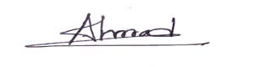

AHMAD SIDDIQUE FORHAD

