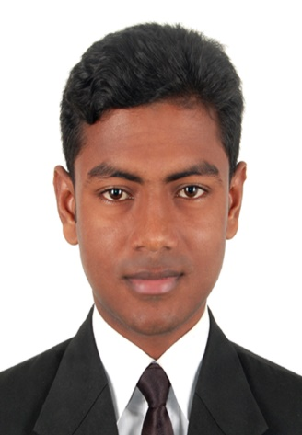

Md. Mahfujul Haque Mailing Address:
Al-Marzan Shopping Complex 6th floor, Zindabazar, Sylhet 3100
Bangladesh.
Mobile: +8801738069084
Email: mahfuj.npi@gmail.com

Career Objective

- Looking forward to an opportunity for working in a dynamic, challenging environment where I can utilize my skills for developing my career and for the growth of the organization.

Expertise Summary

- Programming Skill: Html-5, Css-3,Bootstarp, WordPress, Php, Java Script, ASP.net(MVC),
- Database: MySQL, SQL.
- Operating System: Windows XP, Windows 7, Windows 8. Windows 10, Windows server 2012, 2014.
- Software Application: MS Office , Adobe Photoshop, Ulead Video studio 11, Nero etc.
- Networking: CCNA (Routing & Switching).

Completed Projects
- www.sylhetchamber.org.bd
- www.cne.com.bd
- www.atoma.com.bd
- www.nra.com.bd
- www.prodippal.com
- www.nssbd.org
- Jalalabad Gas Inventory Software
- Sylhet International University LAB Equipment Management Software.

Experience
1.
- Company Name : Staff-India
- Company Business : Outsourcing.
- Company Location : Block-A, Main Road, Uposhahar, Sylhet 3100.
- Company Website: staff-india.com
- Position Held : Virtual Staff
- From : December 01, 2014
- To : 6th June 2016

2.
- Company Name : C&E IT Solutions.
- Company Business : Software Development.
- Company Location : Manru Shopping Complex 3rd floor,Chouhatta , Sylhet 3100.
- Company Website: cne.com.bd
- Position Held : Web Developer Cum Software Support Engineer
- From : December 01, 2016
- To : Continue.

3.
- Company Name : Advanced Technology Training Center.
- Company Business : Training Center
- Company Location : Century Shopping Complex 1rd floor,Amborkhana , Sylhet 3100.
- Position Held : Trainer (CCNA)
- From : February 05,2018
- To : May 10, 2018

Special Qualification

- Software Deployment, Support & Training.
- Web Development.
- Graphics Design.
- All computer hardware accessories driver software installs & configure.
- Delete, remove, format & patrician file recover.
- Video Editing.

Training Summary

- Webpage Design & Development courses at Optimal It Ltd. 1/17 (1st Floor). Humayun Road, Mohammadpur, Dhaka-1207

Language Proficiency

- Fluent in reading, writing, speaking and understanding in both Bangla and English.

Other Activities and interests

- Travelling
- Reading & Writing.
- Music.
- Facebook.
- Internet Browsing.

Achievements

- Got Stipend in Naogaon Polytechnic Institute.
- Got Skill and Training Enhancement Project (STEP) scholarship from World Bank.

Academic Qualification

BSc. Engineering in Computer Science & Engineering:
Sylhet International University:
Main Stream: Software Development
Passing year: 2018
Overall CGPA: 3.43 on scale of 4.00

Diploma Engineering in Computer Technology
Naogaon Polytechnic Institute.
Main Stream: Webpage design & Development, Computer servicing.
Semester completed: 8th out of 8th
Passing year: 2015
Overall CGPA: 3.28 on scale of 4.00

Secondary School Certificate.
Aihai High School
Passing Year: 2010
GPA: 4.38 on scale of 5.00 (Group of science)

Personal Strengths

- Highly motivated, self-disciplined, good team organizer, and pleasantly adaptable.
- Always keen to take on responsibility and possess strong leadership qualities. Work under pressure at a fast pace and committed to professionalism.

Personal Information

Father : Md. Abdul Latif
Mother : Most. Rubeda Bibi
Date of Birth : 06 May 1994
Marital Status : Single
Nationality : Bangladeshi
National ID No : 5051975927
Permanent Address : Vill: Babuk, Post: Asharanda, Thana: Sapaher, Dist: Naogaon 6500, Bangladesh
Current Location : Al-Marzan Shopping Complex 6th floor, Zindabazar, Sylhet 3100, Bangladesh.

References

Md. Abul Bashar Biswaprio Chakrabarty
Senior Web Developer Lecturer at Shahjalal University of Science
At Optimal It Ltd. & Technology , Sylhet
Mobile: 01718792556 Mobile: +88016123009
Email: a.bashar042@gmail.com Email: biswapriyo.chakrabarty@gmail.com
Relation: Academic Relation: Academic

