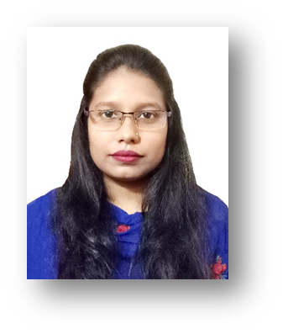 |  | SENTHEA REZA ANONNA
PROFILE___________________  Seeking a challenging career in a leading company where I can build effective HR career and can add value to their operation system, deliver unique solutions and manage rapid & sustain growth to the organization.  CONTACT__________________  Phone  +8801716313532  E-mail  fsenthearezaanonna@gmail.com  LinkedIn  linkedin.com/in/senthea-reza  SPECIAL COURSE____________  Human Resource Management Competencies (HRMC)  IBA, Dhaka University  Web Development  LICT  SKILLS & EXPERTISE__________  - Good communication & presentation skill and a fluent speaker.  - Team management skill, Decision making skill, Good analytic and leadership skill.  - Ability to handle pressure; work under tight deadlines.  - Good command in English Writing & Speaking.  - Expert in basic use of computer like; MS office, Google docs.  - Internet Browsing & Web Mailing.  PERSONAL INFORMATION____  Present Address: 325/A, ChairmanGoli, Noyatola, Moghbazar, Dhaka  Permanent Address: House no: 69, Bablu Sorok, Mohammadnagar, Gollamari, Khulna  Date of Birth : 05.11.1992  Nationality : Bangladeshi  Religion : Islam  Marital Status : Married |  | WORK EXPERIENCE_____________________________  NEWAYS INTERNATIONAL COMPANY LIMITED  HR Executive  January 2017 – July 2018  - Work with HR Manager to strategically plan about HR initiatives and execute plans.  - Evaluate job description and support organizational development and counseling employees.  - Manage hiring process (job requisitions, skill net matching, networking and screening) and the interview process and references.  - Prepare offer letter, employment contact and job description, complete joining formalities and documentation.  - Work with team for performance management.  - Maintain personal data in HRIS and hard copy records.  - Manage the administrative work that relate to employee compensation and benefits and regulation to ensure Compliance.  - Coordinate and organize effective induction training programs and training center administration.  - HR related legal affairs by labor law.  PROTIK GROUP  Office Executive  January 2016 – December 2016  - To address entire external & internal clients/ Visitors/ Officers/ Staffs and other.  - Maintain PABX calls.  - Dispatch letters and other correspondences.  - Entry all types of documents/ bill/voucher etc.  - Store all types of Documents/Papers coming from outside and distribute the documents/papers to the concerned officials.  - Look after the general admin, related works.  - Check attendance register, time register, movement register etc.  - Follow up superior instructions, orders and advice as all time basis.  - Maintain excellent behavior to all other officials & staffs.  - Strictly follow and maintain the administrative rules and regulations, reign customer and correspondences over phone and email.  EDUCATION___________________________________  M.Sc in Human Resource Development & Industrial Relation  Department of Public Administration  Jahangirnagar University  2018- 2019  B.Sc in Petroleum & Mining Engineering  Department of Engineering  Jessore University Of Science & Technology  2011-2014  Higher Secondary Certificate  Science Group  Jessore Board  2009  Secondary School Certificate  Science Group  Jessore Board  2007

REFERANCE___________________________________
Md Tareq Hasan  Officer, HR & Admin  Ananta Group, Savar,  Dhaka  Email:tareqzemtex@gmail.com  Contact: 01680 549883 | Foysal Ahmed  Junior Officer  IDLC Finance Limited  Keranigonj Branch, Dhaka  foysalahmeddinar@gmail.com  Contact: 01712984815

Senthea Reza Anonna

