Contact Details  AJOY PAUL  Date of Birth : 10-6-1994  3/1, Prosanno Podder Lane,  Tatibazar,  Dhaka - 1100  Phone: +8801821716225  E-mail : ajoy2175@gmail.com | 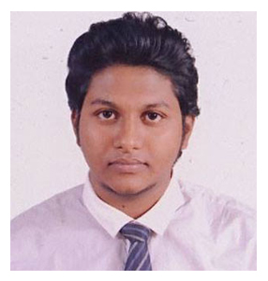
Academic Background

Examination Bachelor Of Fine Arts (major in painting)
Institution University of Development Alternative (UODA)
Session 2015 (present)
Passing Year Appeared
Result Appeared

Exhibition

- 12th Art Exhibition & Competition 2017 of Shilpi Rashed Smriti Parshad Jointly
Organized by Shilpi Rashed Smriti Parshad & Bangladesh Shilpakala Academy.

These are my credentials in a nutshell, if you are interested or for more information please do contact through above address.
Thanking you
Ajoy Paul

