Curriculum Vitae

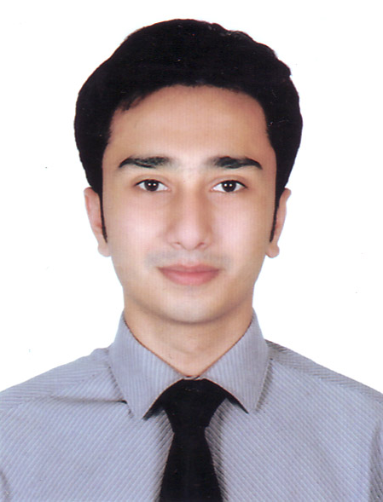

PHOTO
Of

AZFAR EKRAM ULLAH
Sarqume House, Dargahmoholla,
Sylhet, Bangladesh.
Email- azfar.ekram@live.co.uk
Cell: 01717130596

Career Objectives

Work with dedication in an organisation in which I will have the scope to utilise my skills and potentially do something innovative and challenging and from where I will be able to enhance my knowledge and efficiency and add values to organisations.

Scholastic aptitude

- BA (Hons) in Applied Accounting
Anglia Ruskin University, United Kingdom
Passing year: 2011

- GCE A Level (Edexcel)
Anandaniketan, Sylhet, Bangladesh
Passing Year: 2008

- GCE O Level (Edexcel)
Anandaniketan, Sylhet, Bangladesh
Passing Year: 2006

Language Proficiency

Good verbal and written proficiency in both Bangla and English.

Technical skills

- Major Software: MS-Office (MS-Word 2000, MS-Power point, MS-Excel, MS-Access). SPSS.
- Internet: Browsing, E-mail and other communication skills.

Professional Experience

Name and address of the company: North East University Bangladesh (NEUB), Telihaor, Sheikhghat, Sylhet-3100
Position held: Assistant Accounts Officer
Department: Office of the Director of Finance
Duration: 1st April 2017- 30th November 2018

Name and address of the company: Friends In Village Development Bangladesh (FIVDB),
Khadimnagar, Sylhet-3103.
Position held: Executive Associate
Department: Executive Director’s Secretariat
Duration: 17th November, 2012 – 31st August 2016

Responsibilities:
- Coordinating and conducting meetings with donor agencies.
- Set up the strategy for implementing development programmes.
- Prepare Annual, M&E reports.
- Assist the senior management team preparing project proposals.
- Participate in different meeting and workshops.

Name and address of the company: Waitrose (John Lewis Plc),
Knightsbridge,London, UK
Position held: Part time employee
Department: Customer service
Duration: June 2009- October-2011

Responsibilities:
- Assist customers shopping.
- Act as team leader and run shifts.
- Provide quality customer service.
- Ensuring other members of the team complete their assigned task.

Trainings

- AMEX Leadership Academy,Thunder-Bird School, Phoenix, USA
- Monitoring & Evaluation, WINROCK Intl.

Personal Details

Name : Azfar Ekram Ullah
Father’s Name : Zafar Ekram Ullah
Mother’s Name : Tahmina ekram
Present Address and Permanent Address: Sarqume House, Dargahmoholla, Sylhet
Date of Birth : 13-02-1990
Marital Status : Single
Blood group : O+
Nationality : Bangladeshi

References
2. Bazle Mostofa Razee
Associate Director
FIVDB, Sylhet
Cell-01714428021
E-mail-bazle_razee@yahoo.com

- Syed Golam Kibria

Director, AB Bank

Cell- 01715108281

I declare hereby that all information provided here is accurate and up-to-date.

Signature:
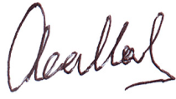

AZFAR EKRAM ULLAH

