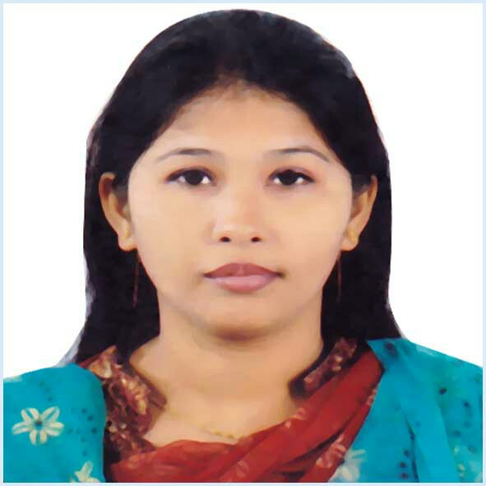
RESUME OF

Bibi Khodeza

Mailing Address:
C/O: Hoque Villa(5th Floor),Road No: 08,
Shantibag R/A, Halishahar, Chittagong.

Cell :+8801670-355585
E-Mail : bibikhodeza@gmail.com

CAREER OBJECTIVES

- To make true my long cherished dream of being an excellent researcher.
- To build-up career with internationally recognized Research Organization and academic Institutions.
- To contribute my knowledge, creativity and leadership quality for the Country.

EDUCATION

Degree/Exam | Institute/University | Passing Year | Result
Master’s in Economics | Noakhali Govt. College | 2013 | 1st Class
Hon’s in Economics | Noakhali Govt. College | 2012 | 2nd Class
H.S.C. (Science Group) | Sonapur College, Comilla Board | 2008 | GPA-2.40 out of 5
S.S.C. (Science Group) | Kalitara Muslim Girls High School, Comilla Board | 2004 | GPA-3.63 out of 5

STRENGTH

- Multi-tasking ability

Able to work under pressure.

Have a creative and innovative approach.

Enthusiastic to learn new things.

Possess a strong interpersonal & communication skill.

LANGUAGE SKILLS

- Fluent in reading, writing, speaking and listening in English
- English as medium of instruction in BSS Honors and M.S.S studies

FIELD OF INTEREST

- Gardening, Reading Books, Traveling, Perform as a Dancer, Debiting & Poetry Recitation.
COMPUTER SKILLS

- Microsoft Word, Excel, PowerPoint,MS. Access & Surfing Internet.

PERSONAL INFORMATION

Full Name : Bibi Khodeza
Father’sName : Ala Uddin
Mother’sName : Bibi Morium
Date of Birth : 05-October -1988
Sex : Female
Marital Status : Married
Height : 5’.3”
Weight : 60 Kg
Blood Group : O+(Positive)
Nationality : Bangladeshi by birth
National ID NO :19887518780273386
Religion : Islam
Permanent Address :C/O: Anowar Ali Munshi Bari, Vill-Kazir Khil , PO- Kazir Khil-3862,
PS- Senbagh, Dist- Noakhali.

PROCLAMATION

I do hereby declare that the particulars provided here are true and no misinformation given.

REFERENCES

- Bibi Fatema
Doctor
Sub-Assistant Community Medical Officer.
Lama Upazilla Health Complex
Bandarban, Chittagong, Bangladesh.
Cell : +8801832103664
Email : fatema.fancy@gmail.com
- Md. Mojir ullah
TPS
Metrological Department,
Aambagan,Chittagong, Bangladesh
Cell : +8801670457750

Signature:

_________________
(Bibi Khodeza)

Date: ......................

